UNITED STATES
SECURITIES AND EXCHANGE COMMISSION
Washington, D.C. 20549

SCHEDULE 14A
Proxy Statement Pursuant to Section 14(a) of the
Securities Exchange Act of 1934

Filed by the Registrant ☒

Filed by a party other than the Registrant ☐

Check the appropriate box:

☐ | Preliminary Proxy Statement

☐ | Confidential, for Use of the Commission Only (as permitted by Rule 14a-6(e)(2))

☐ | Definitive Proxy Statement

☐ | Definitive Additional Materials

☒ | Soliciting Material Pursuant to §240.14a-12

APOGEE THERAPEUTICS, INC.
(Name of Registrant as Specified in its Charter)

(Name of Person(s) Filing Proxy Statement, if other than the Registrant)

Payment of Filing Fee (Check the appropriate box):

☒ | No fee required.

☐ | Fee paid previously with preliminary materials.

☐ | Fee computed on table in exhibit required by Item 25(b) per Exchange Act Rules 14a-6(i)(1) and 0-11.

This Schedule 14A relates solely to preliminary communications made prior to furnishing security holders of Apogee Therapeutics, Inc. (“Apogee” or the “Company”) with a proxy statement related to a proposed transaction in which Andor Merger Co. (“Merger Sub”), a Delaware corporation and wholly owned subsidiary of Andor LLC (“Parent”), a Delaware limited liability company and a wholly owned subsidiary of AbbVie Inc. (“AbbVie”), will merge with and into the Company (the “Merger”), with the Company surviving the Merger as a wholly owned subsidiary of Parent, upon the terms and subject to the conditions set forth in the Agreement and Plan of Merger, dated June 18, 2026, among Parent, Merger Sub, the Company, and solely for the limited purposes set forth therein, AbbVie.

This Schedule 14A filing consists of the following documents relating to the Merger:

Exhibit 99.1: All Team Email
Exhibit 99.2: Employee FAQ
Exhibit 99.3: Partner & Vendor Email
Exhibit 99.4: KOL Email
Exhibit 99.5: Principal Investigator Email
Exhibit 99.6: Investor & Analyst Courtesy Note
Exhibit 99.7: LinkedIn Post
Exhibit 99.8: AbbVie Investor Presentation

* * *

Cautionary Statement Regarding Forward-Looking Statements

This communication contains statements that constitute “forward-looking statements” within the meaning of the Private Securities Litigation Reform Act of 1995, Section 27A of the Securities Act of 1933 and Section 21E of the Securities Exchange Act of 1934, each as amended. All statements other than statements of historical fact, including statements regarding market and industry prospects and future results of operations or financial position made in this communication are forward-looking. In many cases, you can identify forward-looking statements by terminology, such as “may,” “should,” “expects,” “intends,” “plans,” “anticipates,” “believes,” “estimates,” “predicts,” “potential,” “continue” or the negative of such terms and other comparable terminology. Statements in this communication that are forward-looking may include, but are not limited to, statements regarding the benefits of the proposed acquisition of Apogee Therapeutics, Inc. (“Apogee”) by AbbVie Inc. (“AbbVie”) and the associated integration plans, anticipated future operating performance and results of Apogee, the expected accretion to AbbVie’s adjusted diluted earnings per share beginning in 2032, the expected timing of the closing of the proposed acquisition and other transactions contemplated by the merger agreement governing the proposed acquisition (the “Merger Agreement”), and the potential of zumilokibart (APG777) and other Apogee’s pipeline assets.

There may also be other statements of expectations, beliefs, future plans and strategies, anticipated events or trends and similar expressions concerning matters that are not historical facts. Readers are cautioned that any such forward-looking statements are not guarantees of future performance and involve risks and uncertainties, many of which are difficult to predict and are generally outside Apogee’s control, that could cause actual performance or results to differ materially from those expressed in, or implied or projected by, the forward-looking statements. Such risks and uncertainties include, but are not limited to: the occurrence of any event, change or other circumstance that could give rise to the right of Apogee or AbbVie or both of them to terminate the Merger Agreement, including circumstances requiring a party to pay the other party a termination fee pursuant to the Merger Agreement; the failure to obtain applicable regulatory or Apogee stockholder approval in a timely manner or otherwise; the risk that the proposed acquisition may not close in the anticipated timeframe or at all due to one or more of the other closing conditions to the transaction not being satisfied or waived; the possibility of competing acquisition proposals for Apogee; the risk that there may be unexpected costs, charges or expenses resulting from the proposed acquisition; risks related to the ability of Apogee and AbbVie to successfully integrate the businesses and the possibility that such integration may be more difficult, time consuming or costly than expected; risks that the proposed transaction disrupts Apogee’s or AbbVie’s current plans and operations; the risk that certain restrictions during the pendency of the proposed transaction may impact Apogee’s ability to pursue certain business opportunities or strategic transactions; risks related to disruption of each company’s management’s time and attention from ongoing business operations due to the proposed transaction; the risk that any announcements relating to the proposed transaction could have adverse effects on the market price of Apogee’s and/or AbbVie’s common stock, credit ratings or operating results; the risk that the proposed transaction and its announcement could have an adverse effect on the ability of Apogee and AbbVie to retain and hire key personnel, to retain customers and to maintain relationships with each of their respective business partners, suppliers and customers and on their respective operating results and businesses generally; the risk of litigation that could be instituted against the parties to the Merger Agreement or their respective directors, managers or officers and/or regulatory actions related to the proposed acquisition, including the effects of any outcomes related thereto; the risk that zumilokibart (APG777) or APG273 and other Apogee’s pipeline assets may not demonstrate the anticipated success, safety, or efficacy in ongoing or future clinical trials; the risk that positive Phase 2 and Phase 1b interim results for zumilokibart (APG777) may not be predictive of results in later-stage or larger clinical trials; challenges to intellectual property; adverse litigation or government action; competition from other products; difficulties inherent in the research and development process; risks related to unpredictable and severe or catastrophic events, including but not limited to acts of terrorism, war or hostilities, cyber attacks, or the impact of any pandemic, epidemic or outbreak of an infectious disease in the United States or worldwide on Apogee’s or AbbVie’s business, financial condition and results of operations, as well as the response thereto by each company’s management; and other business effects, including the effects of industry, market, economic, political or regulatory conditions.

Also, AbbVie’s and Apogee’s actual results may differ materially from those contemplated by the forward-looking statements for a number of additional reasons as described in AbbVie’s and Apogee’s filings with the Securities and Exchange Commission (the “SEC”), including those set forth in the Risk Factors section and under any “Forward-Looking Statements” or similar heading in AbbVie’s and Apogee’s most recently filed Annual Report on Form 10-K filed on February 20, 2026, and March 2, 2026, respectively, and subsequent Quarterly Reports on Form 10-Q and Current Reports on Form 8-K.

AbbVie and Apogee have based these forward-looking statements on their current expectations and projections about future events. Although the parties believe that the assumptions on which the forward-looking statements contained herein are based are reasonable, any of those assumptions could prove to be inaccurate. As a result, the forward-looking statements based upon those assumptions also could be incorrect. Except to the extent required by law, AbbVie and Apogee undertake no obligation to publicly update or revise any forward-looking statements, whether as a result of new information, future events or otherwise.

Additional Information and Where to Find It

This communication is being made in respect of the proposed transaction involving Apogee and AbbVie. A meeting of the stockholders of Apogee will be announced as promptly as practicable to seek Apogee stockholder approval in connection with the proposed transaction. Apogee intends to file relevant materials with the SEC, including preliminary and definitive proxy statements relating to the proposed transaction. The definitive proxy statement will be mailed to Apogee’s stockholders. This communication is not a substitute for the proxy statement or any other document that may be filed by Apogee with the SEC.

BEFORE MAKING ANY DECISION, APOGEE STOCKHOLDERS ARE URGED TO CAREFULLY READ THE PRELIMINARY AND DEFINITIVE PROXY STATEMENTS (INCLUDING ANY AMENDMENTS OR SUPPLEMENTS THERETO) AND ANY OTHER RELEVANT DOCUMENTS FILED OR TO BE FILED WITH THE SEC IN CONNECTION WITH THE PROPOSED TRANSACTION OR INCORPORATED BY REFERENCE INTO THE PROXY STATEMENT WHEN THEY BECOME AVAILABLE BECAUSE THEY WILL CONTAIN IMPORTANT INFORMATION ABOUT THE PROPOSED TRANSACTION.

Any vote in respect of resolutions to be proposed at Apogee’s stockholder meeting to approve the proposed transaction or other responses in relation to the proposed transaction should be made only on the basis of the information contained in Apogee’s proxy statement. You will be able to obtain a free copy of the proxy statement and other related documents (when available) filed by Apogee with the SEC at the website maintained by the SEC at www.sec.gov or by accessing the Investors section of Apogee’s website at https://investors.apogeetherapeutics.com.

No Offer or Solicitation

This communication is for informational purposes only and is not intended to, and does not constitute or form part of, an offer, invitation or the solicitation of an offer or invitation to purchase, otherwise acquire, subscribe for, sell or otherwise dispose of any securities, or the solicitation of any vote or approval in any jurisdiction, pursuant to the proposed transaction or otherwise, nor shall there be any sale, issuance or transfer of securities in any jurisdiction in contravention of applicable law.

Participants in the Solicitation

Apogee, AbbVie and their respective directors and executive officers and certain of their employees may be deemed to be participants in the solicitation of proxies from Apogee’s stockholders in connection with the proposed transaction. Information regarding Apogee’s directors and executive officers is set forth under the captions “Proposal 1: Election of Directors,” “Corporate Governance,” “Executive Officers,” “Executive Compensation” and “Certain Information About Our Common Stock” in the definitive proxy statement for Apogee’s 2026 Annual Meeting of Stockholders, filed with the SEC on April 24, 2026, and in Apogee’s Current Reports on Form 8-K, filed with the SEC on April 24, 2026, and June 12, 2026. Information regarding AbbVie’s directors and executive officers is set forth under the captions “Information Concerning Director Nominees,” “The Board of Directors and its Committees,” “Director Compensation,” “Securities Ownership” and “Executive Compensation” in the definitive proxy statement for AbbVie’s 2026 Annual Meeting of Stockholders, filed with the SEC on March 23, 2026, and in AbbVie’s Current Report on Form 8-K, filed with the SEC on May 12, 2026. To the extent holdings of Apogee’s securities and AbbVie’s securities by their respective directors or executive officers have changed since the amounts set forth in such filings, such changes have been or will be reflected on Initial Statements of Beneficial Ownership on Form 3 or Statements of Beneficial Ownership on Form 4 filed with the SEC. These documents may be obtained free of charge from the SEC’s website at www.sec.gov or by accessing the Investors section of Apogee’s website at https://investors.apogeetherapeutics.com and the Investors section of AbbVie’s website at https://investors.abbvie.com. Additional information regarding the interests of participants in the solicitation of proxies in connection with the proposed transaction will be included in the proxy statement that Apogee expects to file in connection with the proposed transaction and other relevant materials Apogee may file with the SEC.

Exhibit 99.1

All Team Email

To: | All Team Members

From: | Michael Henderson

Subject: | An Important Update on the Future of Apogee Therapeutics

A-Team,

Since our founding, we have been guided by our vision to reshape the standard of care for people living with inflammatory and immunological conditions. Thanks to each of you, in just four years, we have built something extraordinary, creating a company well positioned to achieve that vision.

Just moments ago, we announced [LINK] that Apogee Therapeutics is taking the next step in our journey. We have entered into an agreement to be acquired by AbbVie for $135.11 per share in cash. This transaction marks a significant milestone for us and underscores the strength of our differentiated portfolio, the compelling clinical data supporting zumilokibart and the tremendous progress we have made toward our Seven Summits this year. It also creates certain value for our shareholders based on the attractive financial terms of the transaction.

As we have advanced our programs through development, our decisions have remained grounded in a fundamental belief: the most important thing we can do is get zumi and the other therapies in our pipeline to as many patients as possible, as quickly as possible. Our commitment to that goal was the driving force behind our decision to enter into this agreement with AbbVie.

AbbVie is a global leader in immunology with extensive Phase 3 development and commercial capabilities. While we have an excellent foundation and the financial strength to move ahead independently, combining our portfolio with AbbVie’s scale, resources and experience will enable us to reach more patients around the world. I am confident this is the right way forward for Apogee and our stakeholders.

In terms of what this means for you, today’s announcement is only the first step in the process to bring our companies together. Our mission remains the same and, for the overwhelming majority of you, it is business as usual. We should all continue to do what we do best: move with urgency, execute with excellence and deliver for patients.

Looking ahead, the transaction is expected to close in the third quarter of 2026, subject to customary closing conditions, including Apogee shareholder approval and receipt of regulatory approvals. Until then, Apogee and AbbVie remain separate companies and will continue to operate independently.

We will have an All Team Call today at 9:00 a.m. PT / 12:00 p.m. ET to share more details. As always, please submit questions here. We know there will be many questions, and we will do our best to address them. We will learn more between now and close and will keep you informed as we move ahead. In the meantime, attached is a set of FAQs to answer some of the questions that are likely top-of-mind for you.

Please take a moment today to reflect on what we have accomplished together. Building a company capable of taking this step with a partner like AbbVie happened because of you and our shared belief that people living with inflammatory and immunological conditions deserve far better than status quo. Thank you for believing in our mission and for refusing to stop at “good enough” in everything we do.

Michael Henderson

#OneTeamOneDream
Confidential; for internal use only

Page 1 of 3

Cautionary Statement Regarding Forward-Looking Statements

This communication contains statements that constitute “forward-looking statements” within the meaning of the Private Securities Litigation Reform Act of 1995, Section 27A of the Securities Act of 1933 and Section 21E of the Securities Exchange Act of 1934, each as amended. All statements other than statements of historical fact, including statements regarding market and industry prospects and future results of operations or financial position made in this communication are forward-looking. In many cases, you can identify forward-looking statements by terminology, such as “may,” “should,” “expects,” “intends,” “plans,” “anticipates,” “believes,” “estimates,” “predicts,” “potential,” “continue” or the negative of such terms and other comparable terminology. Statements in this communication that are forward-looking may include, but are not limited to, statements regarding the benefits of the proposed acquisition of Apogee Therapeutics, Inc. (“Apogee”) by AbbVie Inc. (“AbbVie”) and the associated integration plans, anticipated future operating performance and results of Apogee, the expected accretion to AbbVie’s adjusted diluted earnings per share beginning in 2032, the expected timing of the closing of the proposed acquisition and other transactions contemplated by the merger agreement governing the proposed acquisition (the “Merger Agreement”), and the potential of zumilokibart (APG777) and other Apogee’s pipeline assets.

There may also be other statements of expectations, beliefs, future plans and strategies, anticipated events or trends and similar expressions concerning matters that are not historical facts. Readers are cautioned that any such forward-looking statements are not guarantees of future performance and involve risks and uncertainties, many of which are difficult to predict and are generally outside Apogee’s control, that could cause actual performance or results to differ materially from those expressed in, or implied or projected by, the forward-looking statements. Such risks and uncertainties include, but are not limited to: the occurrence of any event, change or other circumstance that could give rise to the right of Apogee or AbbVie or both of them to terminate the Merger Agreement, including circumstances requiring a party to pay the other party a termination fee pursuant to the Merger Agreement; the failure to obtain applicable regulatory or Apogee stockholder approval in a timely manner or otherwise; the risk that the proposed acquisition may not close in the anticipated timeframe or at all due to one or more of the other closing conditions to the transaction not being satisfied or waived; the possibility of competing acquisition proposals for Apogee; the risk that there may be unexpected costs, charges or expenses resulting from the proposed acquisition; risks related to the ability of Apogee and AbbVie to successfully integrate the businesses and the possibility that such integration may be more difficult, time consuming or costly than expected; risks that the proposed transaction disrupts Apogee’s or AbbVie’s current plans and operations; the risk that certain restrictions during the pendency of the proposed transaction may impact Apogee’s ability to pursue certain business opportunities or strategic transactions; risks related to disruption of each company’s management’s time and attention from ongoing business operations due to the proposed transaction; the risk that any announcements relating to the proposed transaction could have adverse effects on the market price of Apogee’s and/or AbbVie’s common stock, credit ratings or operating results; the risk that the proposed transaction and its announcement could have an adverse effect on the ability of Apogee and AbbVie to retain and hire key personnel, to retain customers and to maintain relationships with each of their respective business partners, suppliers and customers and on their respective operating results and businesses generally; the risk of litigation that could be instituted against the parties to the Merger Agreement or their respective directors, managers or officers and/or regulatory actions related to the proposed acquisition, including the effects of any outcomes related thereto; the risk that zumilokibart (APG777) or APG273 and other Apogee’s pipeline assets may not demonstrate the anticipated success, safety, or efficacy in ongoing or future clinical trials; the risk that positive Phase 2 and Phase 1b interim results for zumilokibart (APG777) may not be predictive of results in later-stage or larger clinical trials; challenges to intellectual property; adverse litigation or government action; competition from other products; difficulties inherent in the research and development process; risks related to unpredictable and severe or catastrophic events, including but not limited to acts of terrorism, war or hostilities, cyber attacks, or the impact of any pandemic, epidemic or outbreak of an infectious disease in the United States or worldwide on Apogee’s or AbbVie’s business, financial condition and results of operations, as well as the response thereto by each company’s management; and other business effects, including the effects of industry, market, economic, political or regulatory conditions.

Also, AbbVie’s and Apogee’s actual results may differ materially from those contemplated by the forward-looking statements for a number of additional reasons as described in AbbVie’s and Apogee’s filings with the Securities and Exchange Commission (the “SEC”), including those set forth in the Risk Factors section and under any “Forward-Looking Statements” or similar heading in AbbVie’s and Apogee’s most recently filed Annual Report on Form 10-K filed on February 20, 2026 and March 2, 2026, respectively, and subsequent Quarterly Reports on Form 10-Q and Current Reports on Form 8-K.

AbbVie and Apogee have based these forward-looking statements on their current expectations and projections about future events. Although the parties believe that the assumptions on which the forward-looking statements contained herein are based are reasonable, any of those assumptions could prove to be inaccurate. As a result, the forward-looking statements based upon those assumptions also could be incorrect. Except to the extent required by law, AbbVie and Apogee undertake no obligation to publicly update or revise any forward-looking statements, whether as a result of new information, future events or otherwise.

Page 2 of 3

Additional Information and Where to Find It

This communication is being made in respect of the proposed transaction involving Apogee and AbbVie. A meeting of the stockholders of Apogee will be announced as promptly as practicable to seek Apogee stockholder approval in connection with the proposed transaction. Apogee intends to file relevant materials with the SEC, including preliminary and definitive proxy statements relating to the proposed transaction. The definitive proxy statement will be mailed to Apogee’s stockholders. This communication is not a substitute for the proxy statement or any other document that may be filed by Apogee with the SEC.

BEFORE MAKING ANY DECISION, APOGEE STOCKHOLDERS ARE URGED TO CAREFULLY READ THE PRELIMINARY AND DEFINITIVE PROXY STATEMENTS (INCLUDING ANY AMENDMENTS OR SUPPLEMENTS THERETO) AND ANY OTHER RELEVANT DOCUMENTS FILED OR TO BE FILED WITH THE SEC IN CONNECTION WITH THE PROPOSED TRANSACTION OR INCORPORATED BY REFERENCE INTO THE PROXY STATEMENT WHEN THEY BECOME AVAILABLE BECAUSE THEY WILL CONTAIN IMPORTANT INFORMATION ABOUT THE PROPOSED TRANSACTION.

Any vote in respect of resolutions to be proposed at Apogee’s stockholder meeting to approve the proposed transaction or other responses in relation to the proposed transaction should be made only on the basis of the information contained in Apogee’s proxy statement. You will be able to obtain a free copy of the proxy statement and other related documents (when available) filed by Apogee with the SEC at the website maintained by the SEC at www.sec.gov or by accessing the Investors section of Apogee’s website at https://investors.apogeetherapeutics.com.

No Offer or Solicitation

This communication is for informational purposes only and is not intended to, and does not constitute or form part of, an offer, invitation or the solicitation of an offer or invitation to purchase, otherwise acquire, subscribe for, sell or otherwise dispose of any securities, or the solicitation of any vote or approval in any jurisdiction, pursuant to the proposed transaction or otherwise, nor shall there be any sale, issuance or transfer of securities in any jurisdiction in contravention of applicable law.

Participants in the Solicitation

Apogee, AbbVie and their respective directors and executive officers and certain of their employees may be deemed to be participants in the solicitation of proxies from Apogee’s stockholders in connection with the proposed transaction. Information regarding Apogee’s directors and executive officers is set forth under the captions “Proposal 1: Election of Directors,” “Corporate Governance,” “Executive Officers,” “Executive Compensation” and “Certain Information About Our Common Stock” in the definitive proxy statement for Apogee’s 2026 Annual Meeting of Stockholders, filed with the SEC on April 24, 2026, and in Apogee’s Current Reports on Form 8-K, filed with the SEC on April 24, 2026 and June 12, 2026. Information regarding AbbVie’s directors and executive officers is set forth under the captions “Information Concerning Director Nominees,” “The Board of Directors and its Committees,” “Director Compensation,” “Securities Ownership” and “Executive Compensation” in the definitive proxy statement for AbbVie’s 2026 Annual Meeting of Stockholders, filed with the SEC on March 23, 2026, and in AbbVie’s Current Report on Form 8-K, filed with the SEC on May 12, 2026. To the extent holdings of Apogee’s securities and AbbVie’s securities by their respective directors or executive officers have changed since the amounts set forth in such filings, such changes have been or will be reflected on Initial Statements of Beneficial Ownership on Form 3 or Statements of Beneficial Ownership on Form 4 filed with the SEC. These documents may be obtained free of charge from the SEC’s website at www.sec.gov or by accessing the Investors section of Apogee’s website at https://investors.apogeetherapeutics.com and the Investors section of AbbVie’s website at https://investors.abbvie.com. Additional information regarding the interests of participants in the solicitation of proxies in connection with the proposed transaction will be included in the proxy statement that Apogee expects to file in connection with the proposed transaction and other relevant materials Apogee may file with the SEC.

Page 3 of 3

Exhibit 99.2



Employee FAQ

1. | What was announced? What are the benefits for Apogee?

 | • | On Monday June 22, we announced that we have entered into an agreement to be acquired for $135.11 per share in cash.

 | • | This transaction marks a significant milestone for us and underscores the strength of our differentiated portfolio and the compelling clinical data supporting zumilokibart. It also creates certain value for our shareholders based on the attractive financial terms of the transaction.

 | • | As we have advanced our programs through development, our decisions have remained grounded in a fundamental belief: the most important thing we can do is get zumi and the other therapies in our pipeline to as many patients as possible, as quickly as possible. Our commitment to that goal was the driving force behind our decision to enter into this agreement with AbbVie.

2. | Who is AbbVie? Why is it the right partner for Apogee?

 | • | AbbVie is a global leader in immunology with extensive Phase 3 development and commercial capabilities. It has a proven track record of bringing multiple I&I therapies to millions of people around the world.

 | • | Combining our portfolio with AbbVie’s scale, resources and experience will enable us to reach more patients around the globe.

3. | When is the transaction expected to close?

 | • | We expect the transaction to close in the third quarter of 2026, subject to customary closing conditions, including Apogee shareholder approval and receipt of regulatory approvals.

 | • | Until then, Apogee will continue to operate as an independent company.

4. | What does this mean for Apogee’s ongoing and planned clinical trials?

 | • | There are no planned changes to our programs at this time. Between now and close, we remain an independent company and will continue to focus on driving our clinical development efforts forward.

5. | Does this impact the timeline for zumilokibart Phase 3 AD trials?

 | • | No. We are continuing to push hard to start our zumilokibart Phase 3 AD trials later this year.

6. | What does this mean for me and my team? What should we expect between now and close?

 | • | We expect the transaction to close in the third quarter of 2026, subject to customary closing conditions, including Apogee shareholder approval and receipt of regulatory approvals.

 | • | Until then, Apogee will continue to operate as an independent company and, with the exception of those working on the integration planning, it remains business as usual.

 | • | Our mission remains the same, and we are counting on you to continue doing what we do best: moving with urgency, executing with excellence and delivering for patients.

7. | What does this mean for my role? Will I have a job with AbbVie following the close?

 | • | Nothing changes today. With the exception of individuals who will be asked to participate in integration planning and certain specific restrictions in the acquisition agreement (which will be communicated separately to the affected employees), your day-to-day will remain the same.

 | • | Over the coming weeks, leaders from Apogee and AbbVie will begin planning for integration following the close.

 | • | We will have additional updates as we move through that process, and we will keep you informed as decisions are made.

Page 1 of 6



8. | How and when will integration occur?

 | • | In the coming days, we will kick off an integration planning team. This team will partner closely with AbbVie to begin to plan for close. We will share more information as this team kicks off.

9. | Will there be changes to my compensation or benefits as a result of this announcement?

 | • | No, there will be no changes to your compensation or benefits through close.

10. | Will I still be eligible for my annual performance bonus?

 | • | Yes, everyone remains eligible for their annual performance bonus, paid in fiscal Q1 2027.

 | • | As part of this transaction, AbbVie has agreed to guarantee that everyone will receive a bonus at target, providing they remain employed by AbbVie through the end of calendar year 2026.

 | • | If your role is eliminated prior to Q1 2027, you will be eligible to receive a severance package, based on your level. This severance package will include your full year target bonus.

11. | What will happen to my Apogee equity?

 | • | Upon the transaction close, all of your Apogee equity compensation will accelerate and become fully vested. You will receive $135.11 in cash per share of common stock subject to restricted stock and restricted stock unit awards.

 | • | For stock options, you will receive a cash payment for the "spread" (e.g., the positive difference between your grant price and $135.11).

 | • | The cash compensation for your equity will be deposited in your E*TRADE account following the transaction close.

12. | Can I trade Apogee stock between now and the close of the transaction? Will I continue to be subject to trading windows?

 | • | All active 10b5-1 plans that were entered into as of June 18, 2026 will remain active.

 | • | In connection with the transaction, we have implemented a trading blackout, effective immediately. As a result, you are not able to trade at this time.

 | • | We will communicate with employees if we decide to open a trading window after we file our Form 10-Q in August 2026.

13. | What does this announcement mean for Apogee’s ESPP?

 | • | There will be no new offering periods under the ESPP.

 | • | If you are currently participating in the January 1- June 30 offering period, you will still be able to continue to contribute and participate in the ESPP purchase that occurs prior to close, but you will not be able to increase or decrease your rate of contributions, withdraw or make any separate non-payroll contributions.

 | • | If you are not participating in the ESPP, there is no opportunity to start participating.

 | • | Employees who own Apogee ESPP shares at close will receive $135.11 in cash per share in their E*TRADE accounts.

14. | Will I receive severance pay if my role is eliminated?

 | • | If your role is eliminated, you will be eligible for severance, based on your level and in accordance with our existing policies.

Page 2 of 6

15. | I recently joined Apogee and am supposed to receive my new hire grant at the end of the month. What will happen to my new hire grant?

 | • | We are excited to have you as part of the Apogee team and appreciate the important work you are already doing. We also recognize this is an usual situation and will set up a call later today to answer any questions you may have.

 | • | The new hire grant amount outlined in your offer letter will convert to a cash equivalent upon the transaction close. You will then be eligible to receive 25% of the cash amount on each of the first four anniversaries of your hire date, providing you remain employed by AbbVie following the close.

 | • | If your role is eliminated, you will be eligible for a severance package, which will include your new hire grant cash equivalent in full.

16. | I’m currently on a work visa. How does this impact my immigration status?

 | • | There are no expected changes to your employment or immigration status as a result of this announcement, and the transaction should not impact your visa status.

 | • | If your employment status changes, we will provide further information on the impact to your visa.

17. | What should I do if I am approached by the media, shareholders, financial analysts or another third party?

 | • | As always, if you receive any external inquiries, please direct them to Noel Kurdi, Vice President of Investor Relations.

18. | Can I post about the transaction on social media?

 | • | We ask that you do not post, re-post third parties, “like” or comment on anything posted about this announcement on social media other than “liking” or re-posting Apogee’s official posts without commentary.

 | • | Public-company transactions are regulated by the U.S. Securities and Exchange Commission. Because we are all employees of Apogee, anything that we, as individuals, say publicly about the transaction could be attributed to the company and become subject to requirements under U.S. securities laws.

 | • | For that reason, all communications about the transaction must come from designated company spokespeople and follow approved messaging.

 | • | This policy is not intended to restrict communications or actions protected or required by federal, state or local law, or to prevent employees from engaging in legally protected activities or exercising any rights that they may have under Section 7 of the National Labor Relations Act.

19. | What should we say to third party vendors and partners about the transaction?

 | • | We have prepared approved language to use with our third-party partners and vendors, including KOLs and Principal Investigators, and will share this language with relevant team members shortly.

20. | Are there any new processes or approvals required for vendor and partner contracts?

 | • | Yes. Other than ordinary course activities, we may not enter into, amend or modify any contracts during this interim period. Additionally, we may not adopt, amend or terminate any agreements or relationships with consultants or individual service providers outside the ordinary course of business.

 | • | Please reach out to Matt Batters and Gabi White in Legal if you have any questions.

Page 3 of 6

21. | I am currently on a leave of absence (FMLA, STD, LTD, Parental) from Apogee. What happens to my status at close?

 | • | You remain eligible for the leave of absence that was previously approved for the duration of the leave. You will return to either your previous position or an equivalent position when your leave is over.

22. | I have a leave that is planned after the close date. Will I still be eligible for that leave?

 | • | You will be eligible to apply for a leave of absence while you are actively employed by either Apogee or AbbVie.

23. | Are we still hiring?

 | • | We will be pausing hiring until the transaction closes. We will honor all current fully executed offers, including individuals whose start date is in the future.

 | • | The People team will be reaching out to individuals with signed offers who have not yet started later today.

24. | Who should I contact if I have questions?

 | • | We will be setting up an integration questions mailbox shortly. In the meantime, if you have additional questions about this announcement, please reach out to Emily Cox.

Cautionary Statement Regarding Forward-Looking Statements

This communication contains statements that constitute “forward-looking statements” within the meaning of the Private Securities Litigation Reform Act of 1995, Section 27A of the Securities Act of 1933 and Section 21E of the Securities Exchange Act of 1934, each as amended. All statements other than statements of historical fact, including statements regarding market and industry prospects and future results of operations or financial position made in this communication are forward-looking. In many cases, you can identify forward-looking statements by terminology, such as “may,” “should,” “expects,” “intends,” “plans,” “anticipates,” “believes,” “estimates,” “predicts,” “potential,” “continue” or the negative of such terms and other comparable terminology. Statements in this communication that are forward-looking may include, but are not limited to, statements regarding the benefits of the proposed acquisition of Apogee Therapeutics, Inc. (“Apogee”) by AbbVie Inc. (“AbbVie”) and the associated integration plans, anticipated future operating performance and results of Apogee, the expected accretion to AbbVie’s adjusted diluted earnings per share beginning in 2032, the expected timing of the closing of the proposed acquisition and other transactions contemplated by the merger agreement governing the proposed acquisition (the “Merger Agreement”), and the potential of zumilokibart (APG777) and other Apogee’s pipeline assets.

There may also be other statements of expectations, beliefs, future plans and strategies, anticipated events or trends and similar expressions concerning matters that are not historical facts. Readers are cautioned that any such forward-looking statements are not guarantees of future performance and involve risks and uncertainties, many of which are difficult to predict and are generally outside Apogee’s control, that could cause actual performance or results to differ materially from those expressed in, or implied or projected by, the forward-looking statements. Such risks and uncertainties include, but are not limited to: the occurrence of any event, change or other circumstance that could give rise to the right of Apogee or AbbVie or both of them to terminate the Merger Agreement, including circumstances requiring a party to pay the other party a termination fee pursuant to the Merger Agreement; the failure to obtain applicable regulatory or Apogee stockholder approval in a timely manner or otherwise; the risk that the proposed acquisition may not close in the anticipated timeframe or at all due to one or more of the other closing conditions to the transaction not being satisfied or waived; the possibility of competing acquisition proposals for Apogee; the risk that there may be unexpected costs, charges or expenses resulting from the proposed acquisition; risks related to the ability of Apogee and AbbVie to successfully integrate the businesses and the possibility that such integration may be more difficult, time consuming or costly than expected; risks that the proposed transaction disrupts Apogee’s or AbbVie’s current plans and operations; the risk that certain restrictions during the pendency of the proposed transaction may impact Apogee’s ability to pursue certain business opportunities or strategic transactions; risks related to disruption of each company’s management’s time and attention from ongoing business operations due to the proposed transaction; the risk that any announcements relating to the proposed transaction could have adverse effects on the market price of Apogee’s and/or AbbVie’s common stock, credit ratings or operating results; the risk that the proposed transaction and its announcement could have an adverse effect on the ability of Apogee and AbbVie to retain and hire key personnel, to retain customers and to maintain relationships with each of their respective business partners, suppliers and customers and on their respective operating results and businesses generally; the risk of litigation that could be instituted against the parties to the Merger Agreement or their respective directors, managers or officers and/or regulatory actions related to the proposed acquisition, including the effects of any outcomes related thereto; the risk that zumilokibart (APG777) or APG273 and other Apogee’s pipeline assets may not demonstrate the anticipated success, safety, or efficacy in ongoing or future clinical trials; the risk that positive Phase 2 and Phase 1b interim results for zumilokibart (APG777) may not be predictive of results in later-stage or larger clinical trials; challenges to intellectual property; adverse litigation or government action; competition from other products; difficulties inherent in the research and development process; risks related to unpredictable and severe or catastrophic events, including but not limited to acts of terrorism, war or hostilities, cyber attacks, or the impact of any pandemic, epidemic or outbreak of an infectious disease in the United States or worldwide on Apogee’s or AbbVie’s business, financial condition and results of operations, as well as the response thereto by each company’s management; and other business effects, including the effects of industry, market, economic, political or regulatory conditions.

Page 4 of 6

Also, AbbVie’s and Apogee’s actual results may differ materially from those contemplated by the forward-looking statements for a number of additional reasons as described in AbbVie’s and Apogee’s filings with the Securities and Exchange Commission (the “SEC”), including those set forth in the Risk Factors section and under any “Forward-Looking Statements” or similar heading in AbbVie’s and Apogee’s most recently filed Annual Report on Form 10-K filed on February 20, 2026 and March 2, 2026, respectively, and subsequent Quarterly Reports on Form 10-Q and Current Reports on Form 8-K.

AbbVie and Apogee have based these forward-looking statements on their current expectations and projections about future events. Although the parties believe that the assumptions on which the forward-looking statements contained herein are based are reasonable, any of those assumptions could prove to be inaccurate. As a result, the forward-looking statements based upon those assumptions also could be incorrect. Except to the extent required by law, AbbVie and Apogee undertake no obligation to publicly update or revise any forward-looking statements, whether as a result of new information, future events or otherwise.

Additional Information and Where to Find It

This communication is being made in respect of the proposed transaction involving Apogee and AbbVie. A meeting of the stockholders of Apogee will be announced as promptly as practicable to seek Apogee stockholder approval in connection with the proposed transaction. Apogee intends to file relevant materials with the SEC, including preliminary and definitive proxy statements relating to the proposed transaction. The definitive proxy statement will be mailed to Apogee’s stockholders. This communication is not a substitute for the proxy statement or any other document that may be filed by Apogee with the SEC.

BEFORE MAKING ANY DECISION, APOGEE STOCKHOLDERS ARE URGED TO CAREFULLY READ THE PRELIMINARY AND DEFINITIVE PROXY STATEMENTS (INCLUDING ANY AMENDMENTS OR SUPPLEMENTS THERETO) AND ANY OTHER RELEVANT DOCUMENTS FILED OR TO BE FILED WITH THE SEC IN CONNECTION WITH THE PROPOSED TRANSACTION OR INCORPORATED BY REFERENCE INTO THE PROXY STATEMENT WHEN THEY BECOME AVAILABLE BECAUSE THEY WILL CONTAIN IMPORTANT INFORMATION ABOUT THE PROPOSED TRANSACTION.

Any vote in respect of resolutions to be proposed at Apogee’s stockholder meeting to approve the proposed transaction or other responses in relation to the proposed transaction should be made only on the basis of the information contained in Apogee’s proxy statement. You will be able to obtain a free copy of the proxy statement and other related documents (when available) filed by Apogee with the SEC at the website maintained by the SEC at www.sec.gov or by accessing the Investors section of Apogee’s website at https://investors.apogeetherapeutics.com.

No Offer or Solicitation

This communication is for informational purposes only and is not intended to, and does not constitute or form part of, an offer, invitation or the solicitation of an offer or invitation to purchase, otherwise acquire, subscribe for, sell or otherwise dispose of any securities, or the solicitation of any vote or approval in any jurisdiction, pursuant to the proposed transaction or otherwise, nor shall there be any sale, issuance or transfer of securities in any jurisdiction in contravention of applicable law.

Page 5 of 6

Participants in the Solicitation

Apogee, AbbVie and their respective directors and executive officers and certain of their employees may be deemed to be participants in the solicitation of proxies from Apogee’s stockholders in connection with the proposed transaction. Information regarding Apogee’s directors and executive officers is set forth under the captions “Proposal 1: Election of Directors,” “Corporate Governance,” “Executive Officers,” “Executive Compensation” and “Certain Information About Our Common Stock” in the definitive proxy statement for Apogee’s 2026 Annual Meeting of Stockholders, filed with the SEC on April 24, 2026, and in Apogee’s Current Reports on Form 8-K, filed with the SEC on April 24, 2026 and June 12, 2026. Information regarding AbbVie’s directors and executive officers is set forth under the captions “Information Concerning Director Nominees,” “The Board of Directors and its Committees,” “Director Compensation,” “Securities Ownership” and “Executive Compensation” in the definitive proxy statement for AbbVie’s 2026 Annual Meeting of Stockholders, filed with the SEC on March 23, 2026, and in AbbVie’s Current Report on Form 8-K, filed with the SEC on May 12, 2026. To the extent holdings of Apogee’s securities and AbbVie’s securities by their respective directors or executive officers have changed since the amounts set forth in such filings, such changes have been or will be reflected on Initial Statements of Beneficial Ownership on Form 3 or Statements of Beneficial Ownership on Form 4 filed with the SEC. These documents may be obtained free of charge from the SEC’s website at www.sec.gov or by accessing the Investors section of Apogee’s website at https://investors.apogeetherapeutics.com and the Investors section of AbbVie’s website at https://investors.abbvie.com. Additional information regarding the interests of participants in the solicitation of proxies in connection with the proposed transaction will be included in the proxy statement that Apogee expects to file in connection with the proposed transaction and other relevant materials Apogee may file with the SEC.

Page 6 of 6

Exhibit 99.3

Partner & Vendor Email

Subject: An Important Update on the Future of Apogee Therapeutics

[Dear Valued Partner / INSERT CUSTOMARY GREETING],

Today we announced [LINK] that Apogee Therapeutics has entered into an agreement to be acquired by AbbVie. This is an important transaction for our company as we advance our vision to reshape the standard of care for people living with inflammatory and immunological conditions.

Our decisions have always been grounded in a fundamental belief: the most important thing we can do is get zumilokibart and the other therapies in our pipeline to as many patients as possible, as quickly as possible. Our commitment to that goal was the driving force behind our decision to enter into this agreement with AbbVie. Combining our portfolio with AbbVie’s scale, resources and experience will enable us to reach more patients around the world.

We expect the transaction to close in the third quarter of 2026, subject to customary closing conditions, including Apogee shareholder approval and receipt of regulatory approvals. Until then, Apogee will continue to operate as an independent company and it remains business as usual.

There are no expected changes to our existing agreements, and your Apogee contacts remain the same. We will keep you informed as we move ahead and, if you have any questions in the meantime, please don’t hesitate to reach out.

We appreciate the role you have played in helping us reach this milestone. Thank you for your continued partnership and support.

Sincerely,

[NAME
TITLE]

Cautionary Statement Regarding Forward-Looking Statements

This communication contains statements that constitute “forward-looking statements” within the meaning of the Private Securities Litigation Reform Act of 1995, Section 27A of the Securities Act of 1933 and Section 21E of the Securities Exchange Act of 1934, each as amended. All statements other than statements of historical fact, including statements regarding market and industry prospects and future results of operations or financial position made in this communication are forward-looking. In many cases, you can identify forward-looking statements by terminology, such as “may,” “should,” “expects,” “intends,” “plans,” “anticipates,” “believes,” “estimates,” “predicts,” “potential,” “continue” or the negative of such terms and other comparable terminology. Statements in this communication that are forward-looking may include, but are not limited to, statements regarding the benefits of the proposed acquisition of Apogee Therapeutics, Inc. (“Apogee”) by AbbVie Inc. (“AbbVie”) and the associated integration plans, anticipated future operating performance and results of Apogee, the expected accretion to AbbVie’s adjusted diluted earnings per share beginning in 2032, the expected timing of the closing of the proposed acquisition and other transactions contemplated by the merger agreement governing the proposed acquisition (the “Merger Agreement”), and the potential of zumilokibart (APG777) and other Apogee’s pipeline assets.

Page 1 of 3

There may also be other statements of expectations, beliefs, future plans and strategies, anticipated events or trends and similar expressions concerning matters that are not historical facts. Readers are cautioned that any such forward-looking statements are not guarantees of future performance and involve risks and uncertainties, many of which are difficult to predict and are generally outside Apogee’s control, that could cause actual performance or results to differ materially from those expressed in, or implied or projected by, the forward-looking statements. Such risks and uncertainties include, but are not limited to: the occurrence of any event, change or other circumstance that could give rise to the right of Apogee or AbbVie or both of them to terminate the Merger Agreement, including circumstances requiring a party to pay the other party a termination fee pursuant to the Merger Agreement; the failure to obtain applicable regulatory or Apogee stockholder approval in a timely manner or otherwise; the risk that the proposed acquisition may not close in the anticipated timeframe or at all due to one or more of the other closing conditions to the transaction not being satisfied or waived; the possibility of competing acquisition proposals for Apogee; the risk that there may be unexpected costs, charges or expenses resulting from the proposed acquisition; risks related to the ability of Apogee and AbbVie to successfully integrate the businesses and the possibility that such integration may be more difficult, time consuming or costly than expected; risks that the proposed transaction disrupts Apogee’s or AbbVie’s current plans and operations; the risk that certain restrictions during the pendency of the proposed transaction may impact Apogee’s ability to pursue certain business opportunities or strategic transactions; risks related to disruption of each company’s management’s time and attention from ongoing business operations due to the proposed transaction; the risk that any announcements relating to the proposed transaction could have adverse effects on the market price of Apogee’s and/or AbbVie’s common stock, credit ratings or operating results; the risk that the proposed transaction and its announcement could have an adverse effect on the ability of Apogee and AbbVie to retain and hire key personnel, to retain customers and to maintain relationships with each of their respective business partners, suppliers and customers and on their respective operating results and businesses generally; the risk of litigation that could be instituted against the parties to the Merger Agreement or their respective directors, managers or officers and/or regulatory actions related to the proposed acquisition, including the effects of any outcomes related thereto; the risk that zumilokibart (APG777) or APG273 and other Apogee’s pipeline assets may not demonstrate the anticipated success, safety, or efficacy in ongoing or future clinical trials; the risk that positive Phase 2 and Phase 1b interim results for zumilokibart (APG777) may not be predictive of results in later-stage or larger clinical trials; challenges to intellectual property; adverse litigation or government action; competition from other products; difficulties inherent in the research and development process; risks related to unpredictable and severe or catastrophic events, including but not limited to acts of terrorism, war or hostilities, cyber attacks, or the impact of any pandemic, epidemic or outbreak of an infectious disease in the United States or worldwide on Apogee’s or AbbVie’s business, financial condition and results of operations, as well as the response thereto by each company’s management; and other business effects, including the effects of industry, market, economic, political or regulatory conditions.

Also, AbbVie’s and Apogee’s actual results may differ materially from those contemplated by the forward-looking statements for a number of additional reasons as described in AbbVie’s and Apogee’s filings with the Securities and Exchange Commission (the “SEC”), including those set forth in the Risk Factors section and under any “Forward-Looking Statements” or similar heading in AbbVie’s and Apogee’s most recently filed Annual Report on Form 10-K filed on February 20, 2026 and March 2, 2026, respectively, and subsequent Quarterly Reports on Form 10-Q and Current Reports on Form 8-K.

AbbVie and Apogee have based these forward-looking statements on their current expectations and projections about future events. Although the parties believe that the assumptions on which the forward-looking statements contained herein are based are reasonable, any of those assumptions could prove to be inaccurate. As a result, the forward-looking statements based upon those assumptions also could be incorrect. Except to the extent required by law, AbbVie and Apogee undertake no obligation to publicly update or revise any forward-looking statements, whether as a result of new information, future events or otherwise.

Additional Information and Where to Find It

This communication is being made in respect of the proposed transaction involving Apogee and AbbVie. A meeting of the stockholders of Apogee will be announced as promptly as practicable to seek Apogee stockholder approval in connection with the proposed transaction. Apogee intends to file relevant materials with the SEC, including preliminary and definitive proxy statements relating to the proposed transaction. The definitive proxy statement will be mailed to Apogee’s stockholders. This communication is not a substitute for the proxy statement or any other document that may be filed by Apogee with the SEC.

BEFORE MAKING ANY DECISION, APOGEE STOCKHOLDERS ARE URGED TO CAREFULLY READ THE PRELIMINARY AND DEFINITIVE PROXY STATEMENTS (INCLUDING ANY AMENDMENTS OR SUPPLEMENTS THERETO) AND ANY OTHER RELEVANT DOCUMENTS FILED OR TO BE FILED WITH THE SEC IN CONNECTION WITH THE PROPOSED TRANSACTION OR INCORPORATED BY REFERENCE INTO THE PROXY STATEMENT WHEN THEY BECOME AVAILABLE BECAUSE THEY WILL CONTAIN IMPORTANT INFORMATION ABOUT THE PROPOSED TRANSACTION.

Any vote in respect of resolutions to be proposed at Apogee’s stockholder meeting to approve the proposed transaction or other responses in relation to the proposed transaction should be made only on the basis of the information contained in Apogee’s proxy statement. You will be able to obtain a free copy of the proxy statement and other related documents (when available) filed by Apogee with the SEC at the website maintained by the SEC at www.sec.gov or by accessing the Investors section of Apogee’s website at https://investors.apogeetherapeutics.com.

Page 2 of 3

No Offer or Solicitation

This communication is for informational purposes only and is not intended to, and does not constitute or form part of, an offer, invitation or the solicitation of an offer or invitation to purchase, otherwise acquire, subscribe for, sell or otherwise dispose of any securities, or the solicitation of any vote or approval in any jurisdiction, pursuant to the proposed transaction or otherwise, nor shall there be any sale, issuance or transfer of securities in any jurisdiction in contravention of applicable law.

Participants in the Solicitation

Apogee, AbbVie and their respective directors and executive officers and certain of their employees may be deemed to be participants in the solicitation of proxies from Apogee’s stockholders in connection with the proposed transaction. Information regarding Apogee’s directors and executive officers is set forth under the captions “Proposal 1: Election of Directors,” “Corporate Governance,” “Executive Officers,” “Executive Compensation” and “Certain Information About Our Common Stock” in the definitive proxy statement for Apogee’s 2026 Annual Meeting of Stockholders, filed with the SEC on April 24, 2026, and in Apogee’s Current Reports on Form 8-K, filed with the SEC on April 24, 2026 and June 12, 2026. Information regarding AbbVie’s directors and executive officers is set forth under the captions “Information Concerning Director Nominees,” “The Board of Directors and its Committees,” “Director Compensation,” “Securities Ownership” and “Executive Compensation” in the definitive proxy statement for AbbVie’s 2026 Annual Meeting of Stockholders, filed with the SEC on March 23, 2026, and in AbbVie’s Current Report on Form 8-K, filed with the SEC on May 12, 2026. To the extent holdings of Apogee’s securities and AbbVie’s securities by their respective directors or executive officers have changed since the amounts set forth in such filings, such changes have been or will be reflected on Initial Statements of Beneficial Ownership on Form 3 or Statements of Beneficial Ownership on Form 4 filed with the SEC. These documents may be obtained free of charge from the SEC’s website at www.sec.gov or by accessing the Investors section of Apogee’s website at https://investors.apogeetherapeutics.com and the Investors section of AbbVie’s website at https://investors.abbvie.com. Additional information regarding the interests of participants in the solicitation of proxies in connection with the proposed transaction will be included in the proxy statement that Apogee expects to file in connection with the proposed transaction and other relevant materials Apogee may file with the SEC.

Page 3 of 3

Exhibit 99.4

KOL Email

Subject: An Important Update on the Future of Apogee Therapeutics

[Dear NAME / INSERT CUSTOMARY GREETING],

Today we announced [LINK] that Apogee Therapeutics has entered into an agreement to be acquired by AbbVie. This is an important transaction for our company as we advance our vision to reshape the standard of care for people living with inflammatory and immunological conditions.

We are incredibly proud of all that we have achieved since our founding just four years ago, and you have played an essential role in our success. With compelling clinical data supporting zumilokibart and a differentiated portfolio, we have a strong foundation to move ahead independently. At the same time, our decisions have always been grounded in a fundamental belief: the most important thing we can do is get zumilokibart and the other therapies in our pipeline to as many patients as possible, as quickly as possible. Our commitment to that goal was the driving force behind our decision to enter into this agreement with AbbVie.

As you may know, AbbVie is a global leader in immunology with extensive Phase 3 development and commercial capabilities. Combining our portfolio with Abbvie’s scale, resources and experience will enable us to reach more patients around the world. We are confident this is the right path forward for Apogee and the patients we seek to serve.

In terms of next steps, we expect the transaction to close in the third quarter of 2026, subject to customary closing conditions, including Apogee shareholder approval and receipt of government approvals. Until then, Apogee will continue to operate as an independent company and it remains business as usual.

There are no expected changes to how we partner with you, and our teams are as focused as ever on advancing our work to improve the lives of people living with I&I conditions. We are continuing to advance our clinical and development programs, and your Apogee contacts remain thesame. We will keep you informed as we move ahead and, if you have any questions in the meantime, please don’t hesitate to reach out.

Thank you for your ongoing scientific partnership and support of Apogee.

Sincerely,

[NAME
TITLE]

Cautionary Statement Regarding Forward-Looking Statements

This communication contains statements that constitute “forward-looking statements” within the meaning of the Private Securities Litigation Reform Act of 1995, Section 27A of the Securities Act of 1933 and Section 21E of the Securities Exchange Act of 1934, each as amended. All statements other than statements of historical fact, including statements regarding market and industry prospects and future results of operations or financial position made in this communication are forward-looking. In many cases, you can identify forward-looking statements by terminology, such as “may,” “should,” “expects,” “intends,” “plans,” “anticipates,” “believes,” “estimates,” “predicts,” “potential,” “continue” or the negative of such terms and other comparable terminology. Statements in this communication that are forward-looking may include, but are not limited to, statements regarding the benefits of the proposed acquisition of Apogee Therapeutics, Inc. (“Apogee”) by AbbVie Inc. (“AbbVie”) and the associated integration plans, anticipated future operating performance and results of Apogee, the expected accretion to AbbVie’s adjusted diluted earnings per share beginning in 2032, the expected timing of the closing of the proposed acquisition and other transactions contemplated by the merger agreement governing the proposed acquisition (the “Merger Agreement”), and the potential of zumilokibart (APG777) and other Apogee’s pipeline assets.

Page 1 of 3

There may also be other statements of expectations, beliefs, future plans and strategies, anticipated events or trends and similar expressions concerning matters that are not historical facts. Readers are cautioned that any such forward-looking statements are not guarantees of future performance and involve risks and uncertainties, many of which are difficult to predict and are generally outside Apogee’s control, that could cause actual performance or results to differ materially from those expressed in, or implied or projected by, the forward-looking statements. Such risks and uncertainties include, but are not limited to: the occurrence of any event, change or other circumstance that could give rise to the right of Apogee or AbbVie or both of them to terminate the Merger Agreement, including circumstances requiring a party to pay the other party a termination fee pursuant to the Merger Agreement; the failure to obtain applicable regulatory or Apogee stockholder approval in a timely manner or otherwise; the risk that the proposed acquisition may not close in the anticipated timeframe or at all due to one or more of the other closing conditions to the transaction not being satisfied or waived; the possibility of competing acquisition proposals for Apogee; the risk that there may be unexpected costs, charges or expenses resulting from the proposed acquisition; risks related to the ability of Apogee and AbbVie to successfully integrate the businesses and the possibility that such integration may be more difficult, time consuming or costly than expected; risks that the proposed transaction disrupts Apogee’s or AbbVie’s current plans and operations; the risk that certain restrictions during the pendency of the proposed transaction may impact Apogee’s ability to pursue certain business opportunities or strategic transactions; risks related to disruption of each company’s management’s time and attention from ongoing business operations due to the proposed transaction; the risk that any announcements relating to the proposed transaction could have adverse effects on the market price of Apogee’s and/or AbbVie’s common stock, credit ratings or operating results; the risk that the proposed transaction and its announcement could have an adverse effect on the ability of Apogee and AbbVie to retain and hire key personnel, to retain customers and to maintain relationships with each of their respective business partners, suppliers and customers and on their respective operating results and businesses generally; the risk of litigation that could be instituted against the parties to the Merger Agreement or their respective directors, managers or officers and/or regulatory actions related to the proposed acquisition, including the effects of any outcomes related thereto; the risk that zumilokibart (APG777) or APG273 and other Apogee’s pipeline assets may not demonstrate the anticipated success, safety, or efficacy in ongoing or future clinical trials; the risk that positive Phase 2 and Phase 1b interim results for zumilokibart (APG777) may not be predictive of results in later-stage or larger clinical trials; challenges to intellectual property; adverse litigation or government action; competition from other products; difficulties inherent in the research and development process; risks related to unpredictable and severe or catastrophic events, including but not limited to acts of terrorism, war or hostilities, cyber attacks, or the impact of any pandemic, epidemic or outbreak of an infectious disease in the United States or worldwide on Apogee’s or AbbVie’s business, financial condition and results of operations, as well as the response thereto by each company’s management; and other business effects, including the effects of industry, market, economic, political or regulatory conditions.

Also, AbbVie’s and Apogee’s actual results may differ materially from those contemplated by the forward-looking statements for a number of additional reasons as described in AbbVie’s and Apogee’s filings with the Securities and Exchange Commission (the “SEC”), including those set forth in the Risk Factors section and under any “Forward-Looking Statements” or similar heading in AbbVie’s and Apogee’s most recently filed Annual Report on Form 10-K filed on February 20, 2026 and March 2, 2026, respectively, and subsequent Quarterly Reports on Form 10-Q and Current Reports on Form 8-K.

AbbVie and Apogee have based these forward-looking statements on their current expectations and projections about future events. Although the parties believe that the assumptions on which the forward-looking statements contained herein are based are reasonable, any of those assumptions could prove to be inaccurate. As a result, the forward-looking statements based upon those assumptions also could be incorrect. Except to the extent required by law, AbbVie and Apogee undertake no obligation to publicly update or revise any forward-looking statements, whether as a result of new information, future events or otherwise.

Additional Information and Where to Find It

This communication is being made in respect of the proposed transaction involving Apogee and AbbVie. A meeting of the stockholders of Apogee will be announced as promptly as practicable to seek Apogee stockholder approval in connection with the proposed transaction. Apogee intends to file relevant materials with the SEC, including preliminary and definitive proxy statements relating to the proposed transaction. The definitive proxy statement will be mailed to Apogee’s stockholders. This communication is not a substitute for the proxy statement or any other document that may be filed by Apogee with the SEC.

BEFORE MAKING ANY DECISION, APOGEE STOCKHOLDERS ARE URGED TO CAREFULLY READ THE PRELIMINARY AND DEFINITIVE PROXY STATEMENTS (INCLUDING ANY AMENDMENTS OR SUPPLEMENTS THERETO) AND ANY OTHER RELEVANT DOCUMENTS FILED OR TO BE FILED WITH THE SEC IN CONNECTION WITH THE PROPOSED TRANSACTION OR INCORPORATED BY REFERENCE INTO THE PROXY STATEMENT WHEN THEY BECOME AVAILABLE BECAUSE THEY WILL CONTAIN IMPORTANT INFORMATION ABOUT THE PROPOSED TRANSACTION.

Page 2 of 3

Any vote in respect of resolutions to be proposed at Apogee’s stockholder meeting to approve the proposed transaction or other responses in relation to the proposed transaction should be made only on the basis of the information contained in Apogee’s proxy statement. You will be able to obtain a free copy of the proxy statement and other related documents (when available) filed by Apogee with the SEC at the website maintained by the SEC at www.sec.gov or by accessing the Investors section of Apogee’s website at https://investors.apogeetherapeutics.com.

No Offer or Solicitation

This communication is for informational purposes only and is not intended to, and does not constitute or form part of, an offer, invitation or the solicitation of an offer or invitation to purchase, otherwise acquire, subscribe for, sell or otherwise dispose of any securities, or the solicitation of any vote or approval in any jurisdiction, pursuant to the proposed transaction or otherwise, nor shall there be any sale, issuance or transfer of securities in any jurisdiction in contravention of applicable law.

Participants in the Solicitation

Apogee, AbbVie and their respective directors and executive officers and certain of their employees may be deemed to be participants in the solicitation of proxies from Apogee’s stockholders in connection with the proposed transaction. Information regarding Apogee’s directors and executive officers is set forth under the captions “Proposal 1: Election of Directors,” “Corporate Governance,” “Executive Officers,” “Executive Compensation” and “Certain Information About Our Common Stock” in the definitive proxy statement for Apogee’s 2026 Annual Meeting of Stockholders, filed with the SEC on April 24, 2026, and in Apogee’s Current Reports on Form 8-K, filed with the SEC on April 24, 2026 and June 12, 2026. Information regarding AbbVie’s directors and executive officers is set forth under the captions “Information Concerning Director Nominees,” “The Board of Directors and its Committees,” “Director Compensation,” “Securities Ownership” and “Executive Compensation” in the definitive proxy statement for AbbVie’s 2026 Annual Meeting of Stockholders, filed with the SEC on March 23, 2026, and in AbbVie’s Current Report on Form 8-K, filed with the SEC on May 12, 2026. To the extent holdings of Apogee’s securities and AbbVie’s securities by their respective directors or executive officers have changed since the amounts set forth in such filings, such changes have been or will be reflected on Initial Statements of Beneficial Ownership on Form 3 or Statements of Beneficial Ownership on Form 4 filed with the SEC. These documents may be obtained free of charge from the SEC’s website at www.sec.gov or by accessing the Investors section of Apogee’s website at https://investors.apogeetherapeutics.com and the Investors section of AbbVie’s website at https://investors.abbvie.com. Additional information regarding the interests of participants in the solicitation of proxies in connection with the proposed transaction will be included in the proxy statement that Apogee expects to file in connection with the proposed transaction and other relevant materials Apogee may file with the SEC.

Page 3 of 3

Exhibit 99.5

Principal Investigator Email

Subject: An important Update on the Future of Apogee Therapeutics

[Dear NAME / INSERT CUSTOMARY GREETING],

Today we announced [LINK] that Apogee Therapeutics has entered into an agreement to be acquired by AbbVie. This is an important transaction for our company as we advance our vision to reshape the standard of care for people living with inflammatory and immunological conditions.

We are incredibly proud of all that we have achieved since our founding just four years ago, and your commitment to advancing our clinical programs has played an essential role in our success. With compelling clinical data supporting zumilokibart and a differentiated portfolio, we have a strong foundation to move ahead independently. At the same time, our decisions have always been grounded in a fundamental belief: the most important thing we can do is get zumilokibart and the other therapies in our pipeline to as many patients as possible, as quickly as possible. Our commitment to that goal was the driving force behind our decision to enter into this agreement with AbbVie.

As you may know, AbbVie is a global leader in immunology with extensive Phase 3 development and commercial capabilities. Combining our portfolio with AbbVie’s scale, resources and experience will enable us to reach more patients around the world. We are confident this is the right path forward for Apogee and the patients we seek to serve.

In terms of next steps, we expect the transaction to close in the third quarter of 2026, subject to customary closing conditions, including Apogee shareholder approval and receipt of regulatory approvals. Until then, Apogee will continue to operate as an independent company, and it remains business as usual.

There are no expected changes to how we partner with you, and our teams are as focused as ever on advancing our work to improve the lives of people living with I&I conditions. We are continuing to advance our clinical and development programs, and your Apogee contacts remain the same. We will keep you informed as we move ahead and, if you have any questions in the meantime, please don’t hesitate to reach out.

Thank you for your ongoing partnership and support of Apogee.

Sincerely,

[NAME
TITLE]

Cautionary Statement Regarding Forward-Looking Statements

This communication contains statements that constitute “forward-looking statements” within the meaning of the Private Securities Litigation Reform Act of 1995, Section 27A of the Securities Act of 1933 and Section 21E of the Securities Exchange Act of 1934, each as amended. All statements other than statements of historical fact, including statements regarding market and industry prospects and future results of operations or financial position made in this communication are forward-looking. In many cases, you can identify forward-looking statements by terminology, such as “may,” “should,” “expects,” “intends,” “plans,” “anticipates,” “believes,” “estimates,” “predicts,” “potential,” “continue” or the negative of such terms and other comparable terminology. Statements in this communication that are forward-looking may include, but are not limited to, statements regarding the benefits of the proposed acquisition of Apogee Therapeutics, Inc. (“Apogee”) by AbbVie Inc. (“AbbVie”) and the associated integration plans, anticipated future operating performance and results of Apogee, the expected accretion to AbbVie’s adjusted diluted earnings per share beginning in 2032, the expected timing of the closing of the proposed acquisition and other transactions contemplated by the merger agreement governing the proposed acquisition (the “Merger Agreement”), and the potential of zumilokibart (APG777) and other Apogee’s pipeline assets.

Page 1 of 3

There may also be other statements of expectations, beliefs, future plans and strategies, anticipated events or trends and similar expressions concerning matters that are not historical facts. Readers are cautioned that any such forward-looking statements are not guarantees of future performance and involve risks and uncertainties, many of which are difficult to predict and are generally outside Apogee’s control, that could cause actual performance or results to differ materially from those expressed in, or implied or projected by, the forward-looking statements. Such risks and uncertainties include, but are not limited to: the occurrence of any event, change or other circumstance that could give rise to the right of Apogee or AbbVie or both of them to terminate the Merger Agreement, including circumstances requiring a party to pay the other party a termination fee pursuant to the Merger Agreement; the failure to obtain applicable regulatory or Apogee stockholder approval in a timely manner or otherwise; the risk that the proposed acquisition may not close in the anticipated timeframe or at all due to one or more of the other closing conditions to the transaction not being satisfied or waived; the possibility of competing acquisition proposals for Apogee; the risk that there may be unexpected costs, charges or expenses resulting from the proposed acquisition; risks related to the ability of Apogee and AbbVie to successfully integrate the businesses and the possibility that such integration may be more difficult, time consuming or costly than expected; risks that the proposed transaction disrupts Apogee’s or AbbVie’s current plans and operations; the risk that certain restrictions during the pendency of the proposed transaction may impact Apogee’s ability to pursue certain business opportunities or strategic transactions; risks related to disruption of each company’s management’s time and attention from ongoing business operations due to the proposed transaction; the risk that any announcements relating to the proposed transaction could have adverse effects on the market price of Apogee’s and/or AbbVie’s common stock, credit ratings or operating results; the risk that the proposed transaction and its announcement could have an adverse effect on the ability of Apogee and AbbVie to retain and hire key personnel, to retain customers and to maintain relationships with each of their respective business partners, suppliers and customers and on their respective operating results and businesses generally; the risk of litigation that could be instituted against the parties to the Merger Agreement or their respective directors, managers or officers and/or regulatory actions related to the proposed acquisition, including the effects of any outcomes related thereto; the risk that zumilokibart (APG777) or APG273 and other Apogee’s pipeline assets may not demonstrate the anticipated success, safety, or efficacy in ongoing or future clinical trials; the risk that positive Phase 2 and Phase 1b interim results for zumilokibart (APG777) may not be predictive of results in later-stage or larger clinical trials; challenges to intellectual property; adverse litigation or government action; competition from other products; difficulties inherent in the research and development process; risks related to unpredictable and severe or catastrophic events, including but not limited to acts of terrorism, war or hostilities, cyber attacks, or the impact of any pandemic, epidemic or outbreak of an infectious disease in the United States or worldwide on Apogee’s or AbbVie’s business, financial condition and results of operations, as well as the response thereto by each company’s management; and other business effects, including the effects of industry, market, economic, political or regulatory conditions.

Also, AbbVie’s and Apogee’s actual results may differ materially from those contemplated by the forward-looking statements for a number of additional reasons as described in AbbVie’s and Apogee’s filings with the Securities and Exchange Commission (the “SEC”), including those set forth in the Risk Factors section and under any “Forward-Looking Statements” or similar heading in AbbVie’s and Apogee’s most recently filed Annual Report on Form 10-K filed on February 20, 2026 and March 2, 2026, respectively, and subsequent Quarterly Reports on Form 10-Q and Current Reports on Form 8-K.

AbbVie and Apogee have based these forward-looking statements on their current expectations and projections about future events. Although the parties believe that the assumptions on which the forward-looking statements contained herein are based are reasonable, any of those assumptions could prove to be inaccurate. As a result, the forward-looking statements based upon those assumptions also could be incorrect. Except to the extent required by law, AbbVie and Apogee undertake no obligation to publicly update or revise any forward-looking statements, whether as a result of new information, future events or otherwise.

Additional Information and Where to Find It

This communication is being made in respect of the proposed transaction involving Apogee and AbbVie. A meeting of the stockholders of Apogee will be announced as promptly as practicable to seek Apogee stockholder approval in connection with the proposed transaction. Apogee intends to file relevant materials with the SEC, including preliminary and definitive proxy statements relating to the proposed transaction. The definitive proxy statement will be mailed to Apogee’s stockholders. This communication is not a substitute for the proxy statement or any other document that may be filed by Apogee with the SEC.

BEFORE MAKING ANY DECISION, APOGEE STOCKHOLDERS ARE URGED TO CAREFULLY READ THE PRELIMINARY AND DEFINITIVE PROXY STATEMENTS (INCLUDING ANY AMENDMENTS OR SUPPLEMENTS THERETO) AND ANY OTHER RELEVANT DOCUMENTS FILED OR TO BE FILED WITH THE SEC IN CONNECTION WITH THE PROPOSED TRANSACTION OR INCORPORATED BY REFERENCE INTO THE PROXY STATEMENT WHEN THEY BECOME AVAILABLE BECAUSE THEY WILL CONTAIN IMPORTANT INFORMATION ABOUT THE PROPOSED TRANSACTION.

Page 2 of 3

Any vote in respect of resolutions to be proposed at Apogee’s stockholder meeting to approve the proposed transaction or other responses in relation to the proposed transaction should be made only on the basis of the information contained in Apogee’s proxy statement. You will be able to obtain a free copy of the proxy statement and other related documents (when available) filed by Apogee with the SEC at the website maintained by the SEC at www.sec.gov or by accessing the Investors section of Apogee’s website at https://investors.apogeetherapeutics.com.

No Offer or Solicitation

This communication is for informational purposes only and is not intended to, and does not constitute or form part of, an offer, invitation or the solicitation of an offer or invitation to purchase, otherwise acquire, subscribe for, sell or otherwise dispose of any securities, or the solicitation of any vote or approval in any jurisdiction, pursuant to the proposed transaction or otherwise, nor shall there be any sale, issuance or transfer of securities in any jurisdiction in contravention of applicable law.

Participants in the Solicitation

Apogee, AbbVie and their respective directors and executive officers and certain of their employees may be deemed to be participants in the solicitation of proxies from Apogee’s stockholders in connection with the proposed transaction. Information regarding Apogee’s directors and executive officers is set forth under the captions “Proposal 1: Election of Directors,” “Corporate Governance,” “Executive Officers,” “Executive Compensation” and “Certain Information About Our Common Stock” in the definitive proxy statement for Apogee’s 2026 Annual Meeting of Stockholders, filed with the SEC on April 24, 2026, and in Apogee’s Current Reports on Form 8-K, filed with the SEC on April 24, 2026 and June 12, 2026. Information regarding AbbVie’s directors and executive officers is set forth under the captions “Information Concerning Director Nominees,” “The Board of Directors and its Committees,” “Director Compensation,” “Securities Ownership” and “Executive Compensation” in the definitive proxy statement for AbbVie’s 2026 Annual Meeting of Stockholders, filed with the SEC on March 23, 2026, and in AbbVie’s Current Report on Form 8-K, filed with the SEC on May 12, 2026. To the extent holdings of Apogee’s securities and AbbVie’s securities by their respective directors or executive officers have changed since the amounts set forth in such filings, such changes have been or will be reflected on Initial Statements of Beneficial Ownership on Form 3 or Statements of Beneficial Ownership on Form 4 filed with the SEC. These documents may be obtained free of charge from the SEC’s website at www.sec.gov or by accessing the Investors section of Apogee’s website at https://investors.apogeetherapeutics.com and the Investors section of AbbVie’s website at https://investors.abbvie.com. Additional information regarding the interests of participants in the solicitation of proxies in connection with the proposed transaction will be included in the proxy statement that Apogee expects to file in connection with the proposed transaction and other relevant materials Apogee may file with the SEC.

Page 3 of 3

Exhibit 99.6

PRIVILEGED & CONFIDENTIAL

Investor & Analyst Courtesy Note

The following email can be sent via BCC to all the Company’s analysts and top shareholders, or it can be sent to each party individually and personalized using the recipient’s name.

Subject: Apogee Therapeutics to be Acquired by AbbVie for $135.11 per Share in Cash

[NAME],

Apogee Therapeutics just announced [LINK] that we have entered into an agreement to be acquired by AbbVie for $135.11 per share in cash, with a transaction value of approximately $10.9 billion.

This is an exciting transaction that we believe offers substantial value to our shareholders while positioning our programs to realize their full potential and maximize their impact for patients.

AbbVie will hold an investor conference call today at 9:00 a.m. ET, which you can access through its Investor Relations website at investors.abbvie.com.

Best,

Noel

[EMAIL SIGNATURE]

Cautionary Statement Regarding Forward-Looking Statements

This communication contains statements that constitute “forward-looking statements” within the meaning of the Private Securities Litigation Reform Act of 1995, Section 27A of the Securities Act of 1933 and Section 21E of the Securities Exchange Act of 1934, each as amended. All statements other than statements of historical fact, including statements regarding market and industry prospects and future results of operations or financial position made in this communication are forward-looking. In many cases, you can identify forward-looking statements by terminology, such as “may,” “should,” “expects,” “intends,” “plans,” “anticipates,” “believes,” “estimates,” “predicts,” “potential,” “continue” or the negative of such terms and other comparable terminology. Statements in this communication that are forward-looking may include, but are not limited to, statements regarding the benefits of the proposed acquisition of Apogee Therapeutics, Inc. (“Apogee”) by AbbVie Inc. (“AbbVie”) and the associated integration plans, anticipated future operating performance and results of Apogee, the expected accretion to AbbVie’s adjusted diluted earnings per share beginning in 2032, the expected timing of the closing of the proposed acquisition and other transactions contemplated by the merger agreement governing the proposed acquisition (the “Merger Agreement”), and the potential of zumilokibart (APG777) and other Apogee’s pipeline assets.

There may also be other statements of expectations, beliefs, future plans and strategies, anticipated events or trends and similar expressions concerning matters that are not historical facts. Readers are cautioned that any such forward-looking statements are not guarantees of future performance and involve risks and uncertainties, many of which are difficult to predict and are generally outside Apogee’s control, that could cause actual performance or results to differ materially from those expressed in, or implied or projected by, the forward-looking statements. Such risks and uncertainties include, but are not limited to: the occurrence of any event, change or other circumstance that could give rise to the right of Apogee or AbbVie or both of them to terminate the Merger Agreement, including circumstances requiring a party to pay the other party a termination fee pursuant to the Merger Agreement; the failure to obtain applicable regulatory or Apogee stockholder approval in a timely manner or otherwise; the risk that the proposed acquisition may not close in the anticipated timeframe or at all due to one or more of the other closing conditions to the transaction not being satisfied or waived; the possibility of competing acquisition proposals for Apogee; the risk that there may be unexpected costs, charges or expenses resulting from the proposed acquisition; risks related to the ability of Apogee and AbbVie to successfully integrate the businesses and the possibility that such integration may be more difficult, time consuming or costly than expected; risks that the proposed transaction disrupts Apogee’s or AbbVie’s current plans and operations; the risk that certain restrictions during the pendency of the proposed transaction may impact Apogee’s ability to pursue certain business opportunities or strategic transactions; risks related to disruption of each company’s management’s time and attention from ongoing business operations due to the proposed transaction; the risk that any announcements relating to the proposed transaction could have adverse effects on the market price of Apogee’s and/or AbbVie’s common stock, credit ratings or operating results; the risk that the proposed transaction and its announcement could have an adverse effect on the ability of Apogee and AbbVie to retain and hire key personnel, to retain customers and to maintain relationships with each of their respective business partners, suppliers and customers and on their respective operating results and businesses generally; the risk of litigation that could be instituted against the parties to the Merger Agreement or their respective directors, managers or officers and/or regulatory actions related to the proposed acquisition, including the effects of any outcomes related thereto; the risk that zumilokibart (APG777) or APG273 and other Apogee’s pipeline assets may not demonstrate the anticipated success, safety, or efficacy in ongoing or future clinical trials; the risk that positive Phase 2 and Phase 1b interim results for zumilokibart (APG777) may not be predictive of results in later-stage or larger clinical trials; challenges to intellectual property; adverse litigation or government action; competition from other products; difficulties inherent in the research and development process; risks related to unpredictable and severe or catastrophic events, including but not limited to acts of terrorism, war or hostilities, cyber attacks, or the impact of any pandemic, epidemic or outbreak of an infectious disease in the United States or worldwide on Apogee’s or AbbVie’s business, financial condition and results of operations, as well as the response thereto by each company’s management; and other business effects, including the effects of industry, market, economic, political or regulatory conditions.

Page 1 of 3

PRIVILEGED & CONFIDENTIAL
Also, AbbVie’s and Apogee’s actual results may differ materially from those contemplated by the forward-looking statements for a number of additional reasons as described in AbbVie’s and Apogee’s filings with the Securities and Exchange Commission (the “SEC”), including those set forth in the Risk Factors section and under any “Forward-Looking Statements” or similar heading in AbbVie’s and Apogee’s most recently filed Annual Report on Form 10-K filed on February 20, 2026 and March 2, 2026, respectively, and subsequent Quarterly Reports on Form 10-Q and Current Reports on Form 8-K.

AbbVie and Apogee have based these forward-looking statements on their current expectations and projections about future events. Although the parties believe that the assumptions on which the forward-looking statements contained herein are based are reasonable, any of those assumptions could prove to be inaccurate. As a result, the forward-looking statements based upon those assumptions also could be incorrect. Except to the extent required by law, AbbVie and Apogee undertake no obligation to publicly update or revise any forward-looking statements, whether as a result of new information, future events or otherwise.

Additional Information and Where to Find It

This communication is being made in respect of the proposed transaction involving Apogee and AbbVie. A meeting of the stockholders of Apogee will be announced as promptly as practicable to seek Apogee stockholder approval in connection with the proposed transaction. Apogee intends to file relevant materials with the SEC, including preliminary and definitive proxy statements relating to the proposed transaction. The definitive proxy statement will be mailed to Apogee’s stockholders. This communication is not a substitute for the proxy statement or any other document that may be filed by Apogee with the SEC.

BEFORE MAKING ANY DECISION, APOGEE STOCKHOLDERS ARE URGED TO CAREFULLY READ THE PRELIMINARY AND DEFINITIVE PROXY STATEMENTS (INCLUDING ANY AMENDMENTS OR SUPPLEMENTS THERETO) AND ANY OTHER RELEVANT DOCUMENTS FILED OR TO BE FILED WITH THE SEC IN CONNECTION WITH THE PROPOSED TRANSACTION OR INCORPORATED BY REFERENCE INTO THE PROXY STATEMENT WHEN THEY BECOME AVAILABLE BECAUSE THEY WILL CONTAIN IMPORTANT INFORMATION ABOUT THE PROPOSED TRANSACTION.

Any vote in respect of resolutions to be proposed at Apogee’s stockholder meeting to approve the proposed transaction or other responses in relation to the proposed transaction should be made only on the basis of the information contained in Apogee’s proxy statement. You will be able to obtain a free copy of the proxy statement and other related documents (when available) filed by Apogee with the SEC at the website maintained by the SEC at www.sec.gov or by accessing the Investors section of Apogee’s website at https://investors.apogeetherapeutics.com.

No Offer or Solicitation

This communication is for informational purposes only and is not intended to, and does not constitute or form part of, an offer, invitation or the solicitation of an offer or invitation to purchase, otherwise acquire, subscribe for, sell or otherwise dispose of any securities, or the solicitation of any vote or approval in any jurisdiction, pursuant to the proposed transaction or otherwise, nor shall there be any sale, issuance or transfer of securities in any jurisdiction in contravention of applicable law.

Page 2 of 3

PRIVILEGED & CONFIDENTIAL
Participants in the Solicitation

Apogee, AbbVie and their respective directors and executive officers and certain of their employees may be deemed to be participants in the solicitation of proxies from Apogee’s stockholders in connection with the proposed transaction. Information regarding Apogee’s directors and executive officers is set forth under the captions “Proposal 1: Election of Directors,” “Corporate Governance,” “Executive Officers,” “Executive Compensation” and “Certain Information About Our Common Stock” in the definitive proxy statement for Apogee’s 2026 Annual Meeting of Stockholders, filed with the SEC on April 24, 2026, and in Apogee’s Current Reports on Form 8-K, filed with the SEC on April 24, 2026 and June 12, 2026. Information regarding AbbVie’s directors and executive officers is set forth under the captions “Information Concerning Director Nominees,” “The Board of Directors and its Committees,” “Director Compensation,” “Securities Ownership” and “Executive Compensation” in the definitive proxy statement for AbbVie’s 2026 Annual Meeting of Stockholders, filed with the SEC on March 23, 2026, and in AbbVie’s Current Report on Form 8-K, filed with the SEC on May 12, 2026. To the extent holdings of Apogee’s securities and AbbVie’s securities by their respective directors or executive officers have changed since the amounts set forth in such filings, such changes have been or will be reflected on Initial Statements of Beneficial Ownership on Form 3 or Statements of Beneficial Ownership on Form 4 filed with the SEC. These documents may be obtained free of charge from the SEC’s website at www.sec.gov or by accessing the Investors section of Apogee’s website at https://investors.apogeetherapeutics.com and the Investors section of AbbVie’s website at https://investors.abbvie.com. Additional information regarding the interests of participants in the solicitation of proxies in connection with the proposed transaction will be included in the proxy statement that Apogee expects to file in connection with the proposed transaction and other relevant materials Apogee may file with the SEC.

Page 3 of 3

Exhibit 99.7

LinkedIn
Apogee Therapeutics
22 June 2026
Link to Post: https://www.linkedin.com/posts/apogee-therapeutics_we-are-pleased-to-announce-that-apogee-therapeutics-activity-7474779909576560640-SR57

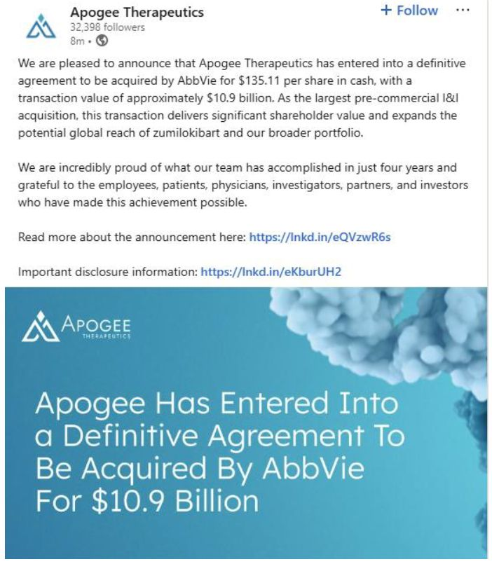

Exhibit 99.8

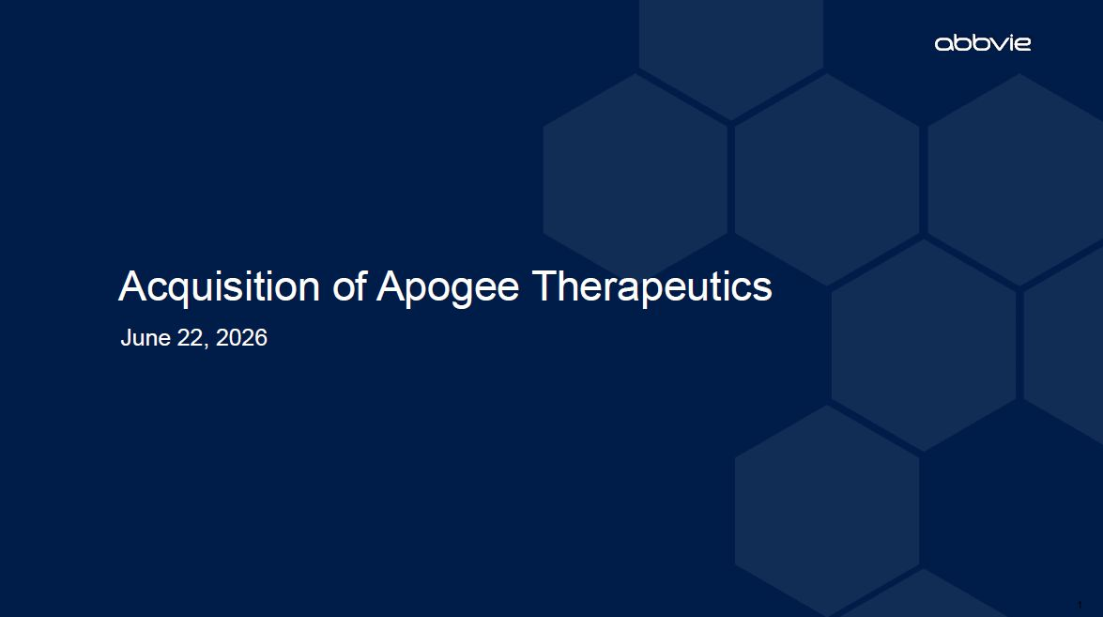
1 Acquisition of Apogee Therapeutics June 22, 2026

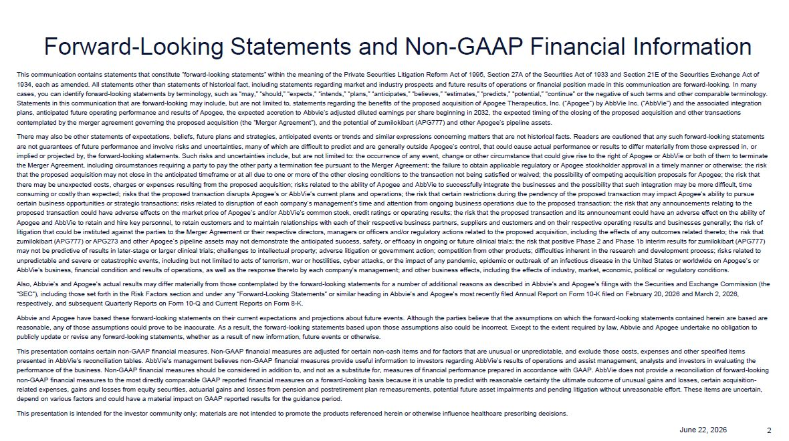
2 June 22, 2026 This communication contains statements that constitute “forward-looking statements” within the meaning of the Private Securities Litigation Reform Act of 1995, Section 27A of the Securities Act of 1933 and Section 21E of the Securities Exchange Act of 1934, each as amended. All statements other than statements of historical fact, including statements regarding market and industry prospects and future results of operations or financial position made in this communication are forward-looking. In many cases, you can identify forward-looking statements by terminology, such as “may,” “should,” “expects,” “intends,” “plans,” “anticipates,” “believes,” “estimates,” “predicts,” “potential,” “continue” or the negative of such terms and other comparable terminology. Statements in this communication that are forward-looking may include, but are not limited to, statements regarding the benefits of the proposed acquisition of Apogee Therapeutics, Inc. (“Apogee”) by AbbVie Inc. (“AbbVie”) and the associated integration plans, anticipated future operating performance and results of Apogee, the expected accretion to Abbvie’s adjusted diluted earnings per share beginning in 2032, the expected timing of the closing of the proposed acquisition and other transactions contemplated by the merger agreement governing the proposed acquisition (the “Merger Agreement”), and the potential of zumilokibart (APG777) and other Apogee’s pipeline assets. There may also be other statements of expectations, beliefs, future plans and strategies, anticipated events or trends and similar expressions concerning matters that are not historical facts. Readers are cautioned that any such forward-looking statements are not guarantees of future performance and involve risks and uncertainties, many of which are difficult to predict and are generally outside Apogee’s control, that could cause actual performance or results to differ materially from those expressed in, or implied or projected by, the forward-looking statements. Such risks and uncertainties include, but are not limited to: the occurrence of any event, change or other circumstance that could give rise to the right of Apogee or AbbVie or both of them to terminate the Merger Agreement, including circumstances requiring a party to pay the other party a termination fee pursuant to the Merger Agreement; the failure to obtain applicable regulatory or Apogee stockholder approval in a timely manner or otherwise; the risk that the proposed acquisition may not close in the anticipated timeframe or at all due to one or more of the other closing conditions to the transaction not being satisfied or waived; the possibility of competing acquisition proposals for Apogee; the risk that there may be unexpected costs, charges or expenses resulting from the proposed acquisition; risks related to the ability of Apogee and AbbVie to successfully integrate the businesses and the possibility that such integration may be more difficult, time consuming or costly than expected; risks that the proposed transaction disrupts Apogee’s or AbbVie’s current plans and operations; the risk that certain restrictions during the pendency of the proposed transaction may impact Apogee’s ability to pursue certain business opportunities or strategic transactions; risks related to disruption of each company’s management’s time and attention from ongoing business operations due to the proposed transaction; the risk that any announcements relating to the proposed transaction could have adverse effects on the market price of Apogee’s and/or AbbVie’s common stock, credit ratings or operating results; the risk that the proposed transaction and its announcement could have an adverse effect on the ability of Apogee and AbbVie to retain and hire key personnel, to retain customers and to maintain relationships with each of their respective business partners, suppliers and customers and on their respective operating results and businesses generally; the risk of litigation that could be instituted against the parties to the Merger Agreement or their respective directors, managers or officers and/or regulatory actions related to the proposed acquisition, including the effects of any outcomes related thereto; the risk that zumilokibart (APG777) or APG273 and other Apogee’s pipeline assets may not demonstrate the anticipated success, safety, or efficacy in ongoing or future clinical trials; the risk that positive Phase 2 and Phase 1b interim results for zumilokibart (APG777) may not be predictive of results in later-stage or larger clinical trials; challenges to intellectual property; adverse litigation or government action; competition from other products; difficulties inherent in the research and development process; risks related to unpredictable and severe or catastrophic events, including but not limited to acts of terrorism, war or hostilities, cyber attacks, or the impact of any pandemic, epidemic or outbreak of an infectious disease in the United States or worldwide on Apogee’s or AbbVie’s business, financial condition and results of operations, as well as the response thereto by each company’s management; and other business effects, including the effects of industry, market, economic, political or regulatory conditions. Also, Abbvie’s and Apogee’s actual results may differ materially from those contemplated by the forward-looking statements for a number of additional reasons as described in Abbvie’s and Apogee’s filings with the Securities and Exchange Commission (the “SEC”), including those set forth in the Risk Factors section and under any “Forward-Looking Statements” or similar heading in Abbvie’s and Apogee’s most recently filed Annual Report on Form 10-K filed on February 20, 2026 and March 2, 2026, respectively, and subsequent Quarterly Reports on Form 10-Q and Current Reports on Form 8-K. Abbvie and Apogee have based these forward-looking statements on their current expectations and projections about future events. Although the parties believe that the assumptions on which the forward-looking statements contained herein are based are reasonable, any of those assumptions could prove to be inaccurate. As a result, the forward-looking statements based upon those assumptions also could be incorrect. Except to the extent required by law, Abbvie and Apogee undertake no obligation to publicly update or revise any forward-looking statements, whether as a result of new information, future events or otherwise. This presentation contains certain non-GAAP financial measures. Non-GAAP financial measures are adjusted for certain non-cash items and for factors that are unusual or unpredictable, and exclude those costs, expenses and other specified items presented in AbbVie’s reconciliation tables. AbbVie’s management believes non-GAAP financial measures provide useful information to investors regarding AbbVie’s results of operations and assist management, analysts and investors in evaluating the performance of the business. Non-GAAP financial measures should be considered in addition to, and not as a substitute for, measures of financial performance prepared in accordance with GAAP. AbbVie does not provide a reconciliation of forward-looking non-GAAP financial measures to the most directly comparable GAAP reported financial measures on a forward-looking basis because it is unable to predict with reasonable certainty the ultimate outcome of unusual gains and losses, certain acquisition-related expenses, gains and losses from equity securities, actuarial gains and losses from pension and postretirement plan remeasurements, potential future asset impairments and pending litigation without unreasonable effort. These items are uncertain, depend on various factors and could have a material impact on GAAP reported results for the guidance period. This presentation is intended for the investor community only; materials are not intended to promote the products referenced herein or otherwise influence healthcare prescribing decisions. Forward-Looking Statements and Non-GAAP Financial Information

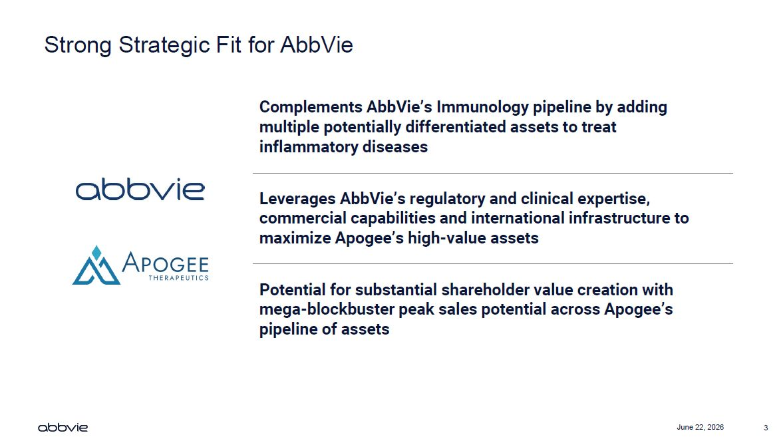
3 June 22, 2026 Strong Strategic Fit for AbbVie Complements AbbVie’s Immunology pipeline by adding multiple potentially differentiated assets to treat inflammatory diseases Leverages AbbVie’s regulatory and clinical expertise, commercial capabilities and international infrastructure to maximize Apogee’s high-value assets Potential for substantial shareholder value creation with mega-blockbuster peak sales potential across Apogee’s pipeline of assets

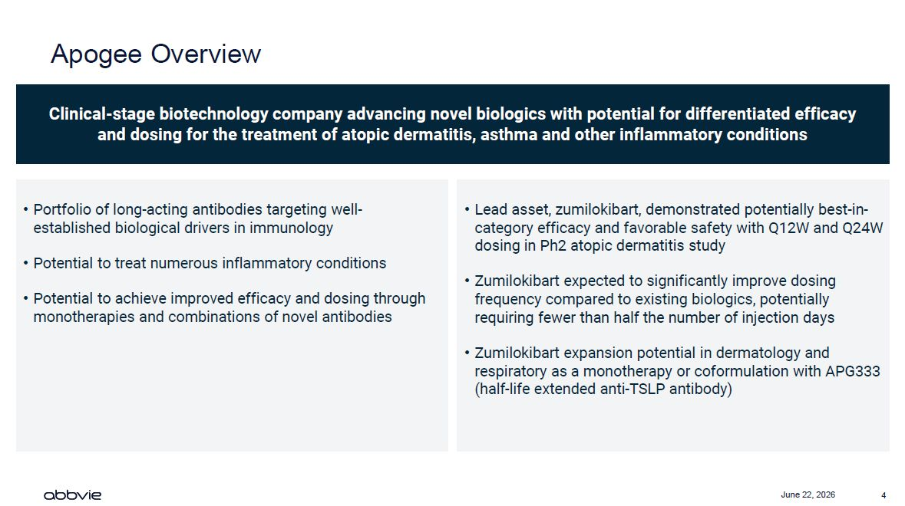
4 June 22, 2026 Apogee Overview Clinical-stage biotechnology company advancing novel biologics with potential for differentiated efficacy and dosing for the treatment of atopic dermatitis, asthma and other inflammatory conditions Portfolio of long-acting antibodies targeting well-established biological drivers in immunology Potential to treat numerous inflammatory conditions Potential to achieve improved efficacy and dosing through monotherapies and combinations of novel antibodies Lead asset, zumilokibart, demonstrated potentially best-in-category efficacy and favorable safety with Q12W and Q24W dosing in Ph2 atopic dermatitis study Zumilokibart expected to significantly improve dosing frequency compared to existing biologics, potentially requiring fewer than half the number of injection days Zumilokibart expansion potential in dermatology and respiratory as a monotherapy or coformulation with APG333 (half-life extended anti-TSLP antibody)

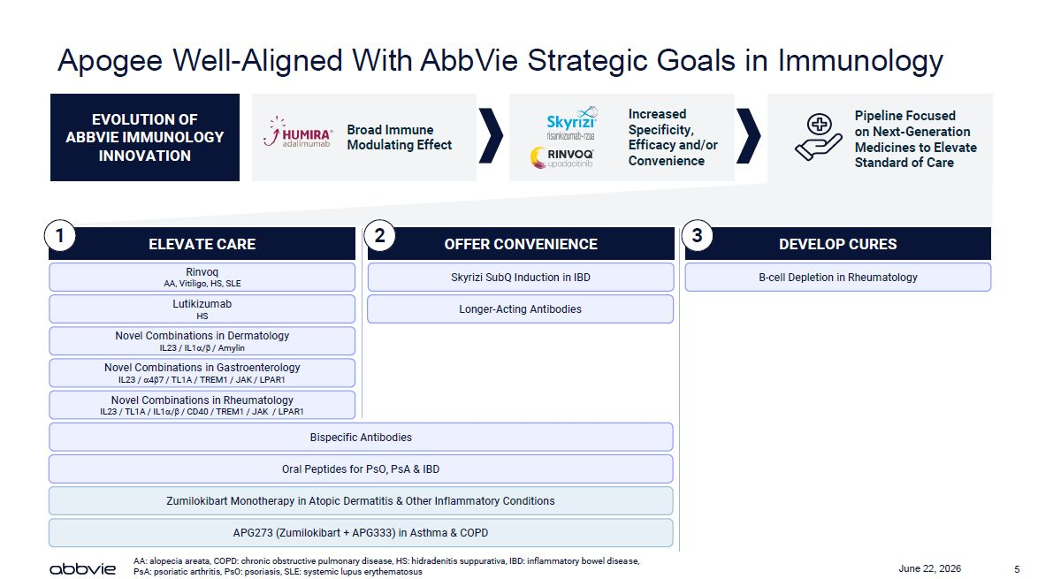
5 June 22, 2026 Apogee Well-Aligned With AbbVie Strategic Goals in Immunology ELEVATE CARE DEVELOP CURES OFFER CONVENIENCE Rinvoq AA, Vitiligo, HS, SLE Lutikizumab HS B-cell Depletion in Rheumatology Skyrizi SubQ Induction in IBD Longer-Acting Antibodies Novel Combinations in Dermatology IL23 / IL1/ / Amylin Novel Combinations in Gastroenterology IL23 / 47 / TL1A / TREM1 / JAK / LPAR1 Novel Combinations in Rheumatology IL23 / TL1A / IL1/ / CD40 / TREM1 / JAK / LPAR1 Bispecific Antibodies Oral Peptides for PsO, PsA & IBD Zumilokibart Monotherapy in Atopic Dermatitis & Other Inflammatory Conditions APG273 (Zumilokibart + APG333) in Asthma & COPD 1 2 3 AA: alopecia areata, COPD: chronic obstructive pulmonary disease, HS: hidradenitis suppurativa, IBD: inflammatory bowel disease, PsA: psoriatic arthritis, PsO: psoriasis, SLE: systemic lupus erythematosus Pipeline Focused on Next-Generation Medicines to Elevate Standard of Care Broad Immune Modulating Effect EVOLUTION OF ABBVIE IMMUNOLOGY INNOVATION Increased Specificity, Efficacy and/or Convenience

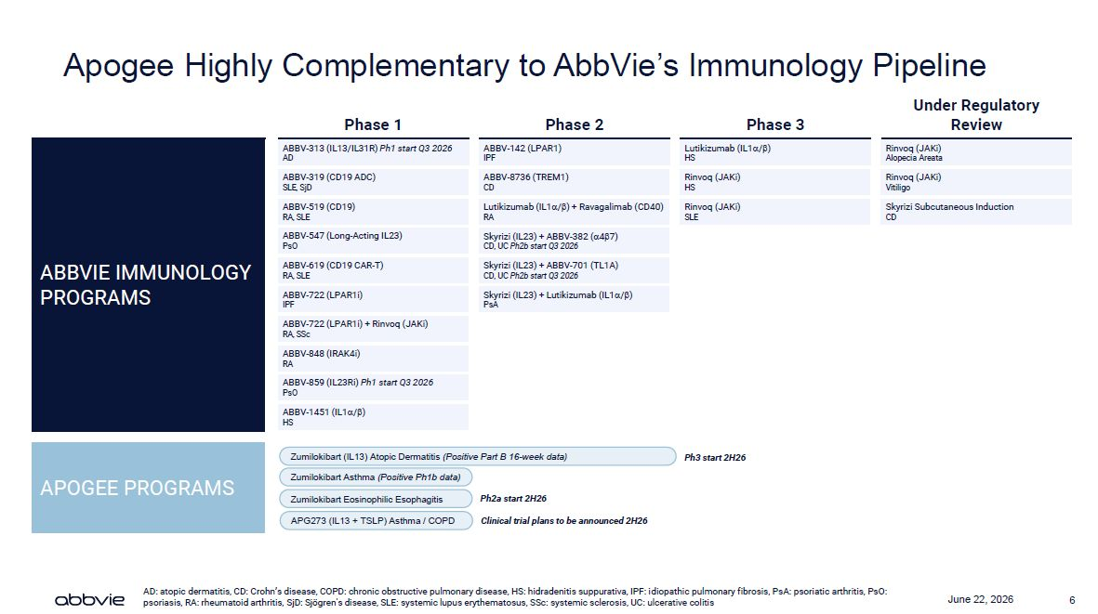
6 June 22, 2026 Apogee Highly Complementary to AbbVie’s Immunology Pipeline iv Phase 1 Phase 2 Phase 3 Under Regulatory Review ABBV-313 (IL13/IL31R) Ph1 start Q3 2026 AD ABBV-142 (LPAR1) IPF Lutikizumab (IL1/) HS Rinvoq (JAKi) Alopecia Areata ABBV-319 (CD19 ADC) SLE, SjD ABBV-8736 (TREM1) CD Rinvoq (JAKi) HS Rinvoq (JAKi) Vitiligo ABBV-519 (CD19) RA, SLE Lutikizumab (IL1/) + Ravagalimab (CD40) RA Rinvoq (JAKi) SLE Skyrizi Subcutaneous Induction CD ABBV-547 (Long-Acting IL23) PsO Skyrizi (IL23) + ABBV-382 (47) CD, UC Ph2b start Q3 2026 ABBVIE IMMUNOLOGY PROGRAMS ABBV-619 (CD19 CAR-T) RA, SLE Skyrizi (IL23) + ABBV-701 (TL1A) CD, UC Ph2b start Q3 2026 ABBV-722 (LPAR1i) IPF Skyrizi (IL23) + Lutikizumab (IL1/) PsA ABBV-722 (LPAR1i) + Rinvoq (JAKi) RA, SSc ABBV-848 (IRAK4i) RA ABBV-859 (IL23Ri) Ph1 start Q3 2026 PsO ABBV-1451 (IL1/) HS Zumilokibart (IL13) Atopic Dermatitis (Posit e Part B 16-week data) Ph3 start 2H26 Zumilokibart Asthma (Positive Ph1b data) APOGEE PROGRAMS Zumilokibart Eosinophilic Esophagitis APG273 (IL13 + TSLP) Asthma / COPD Ph2a start 2H26 Clinical trial plans to be announced 2H26 AD: atopic dermatitis, CD: Crohn’s disease, COPD: chronic obstructive pulmonary disease, HS: hidradenitis suppurativa, IPF: idiopathic pulmonary fibrosis, PsA: psoriatic arthritis, PsO: psoriasis, RA: rheumatoid arthritis, SjD: Sjögren's disease, SLE: systemic lupus erythematosus, SSc: systemic sclerosis, UC: ulcerative colitis

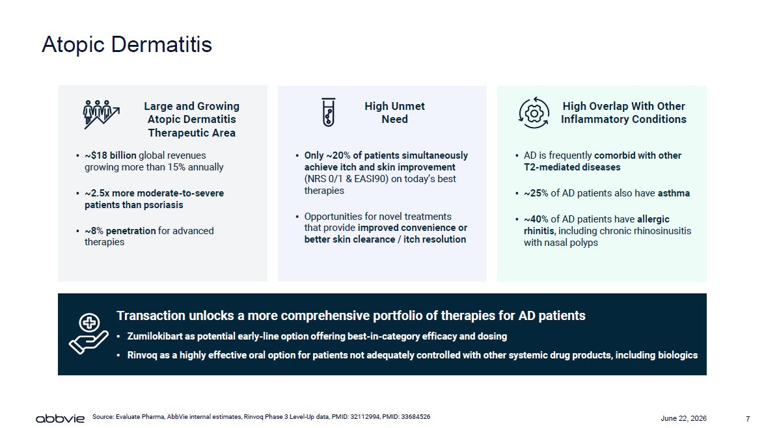
7 June 22, 2026 Atopic Dermatitis Large and Growing Atopic Dermatitis Therapeutic Area ~$18 billion global revenues growing more than 15% annually ~2.5x more moderate-to-severe patients than psoriasis ~8% penetration for advanced therapies High Unmet Need Only ~20% of patients simultaneously achieve itch and skin improvement (NRS 0/1 & EASI90) on today’s best therapies Opportunities for novel treatments that provide improved convenience or better skin clearance / itch resolution High Overlap With Other Inflammatory Conditions AD is frequently comorbid with other T2-mediated diseases ~25% of AD patients also have asthma ~40% of AD patients have allergic rhinitis, including chronic rhinosinusitis with nasal polyps Transaction unlocks a more comprehensive portfolio of therapies for AD patients Zumilokibart as potential early-line option offering best-in-category efficacy and dosing Rinvoq as a highly effective oral option for patients not adequately controlled with other systemic drug products, including biologics Source: Evaluate Pharma, AbbVie internal estimates, Rinvoq Phase 3 Level-Up data, PMID: 32112994, PMID: 33684526

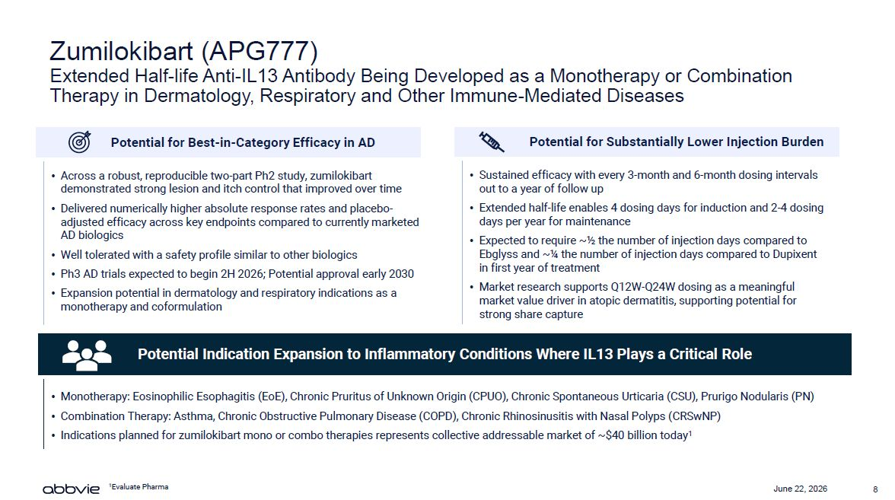
8 June 22, 2026 Zumilokibart (APG777) Extended Half-life Anti-IL13 Antibody Being Developed as a Monotherapy or Combination Therapy in Dermatology, Respiratory and Other Immune-Mediated Diseases Across a robust, reproducible two-part Ph2 study, zumilokibart demonstrated strong lesion and itch control that improved over time Delivered numerically higher absolute response rates and placebo-adjusted efficacy across key endpoints compared to currently marketed AD biologics Well tolerated with a safety profile similar to other biologics Ph3 AD trials expected to begin 2H 2026; Potential approval early 2030 Expansion potential in dermatology and respiratory indications as a monotherapy and coformulation Potential for Best-in-Category Efficacy in AD Sustained efficacy with every 3-month and 6-month dosing intervals out to a year of follow up Extended half-life enables 4 dosing days for induction and 2-4 dosing days per year for maintenance Expected to require ~½ the number of injection days compared to Ebglyss and ~¼ the number of injection days compared to Dupixent in first year of treatment Market research supports Q12W-Q24W dosing as a meaningful market value driver in atopic dermatitis, supporting potential for strong share capture Potential for Substantially Lower Injection Burden Monotherapy: Eosinophilic Esophagitis (EoE), Chronic Pruritus of Unknown Origin (CPUO), Chronic Spontaneous Urticaria (CSU), Prurigo Nodularis (PN) Combination Therapy: Asthma, Chronic Obstructive Pulmonary Disease (COPD), Chronic Rhinosinusitis with Nasal Polyps (CRSwNP) Indications planned for zumilokibart mono or combo therapies represents collective addressable market of ~$40 billion today1 Potential Indication Expansion to Inflammatory Conditions Where IL13 Plays a Critical Role 1Evaluate Pharma

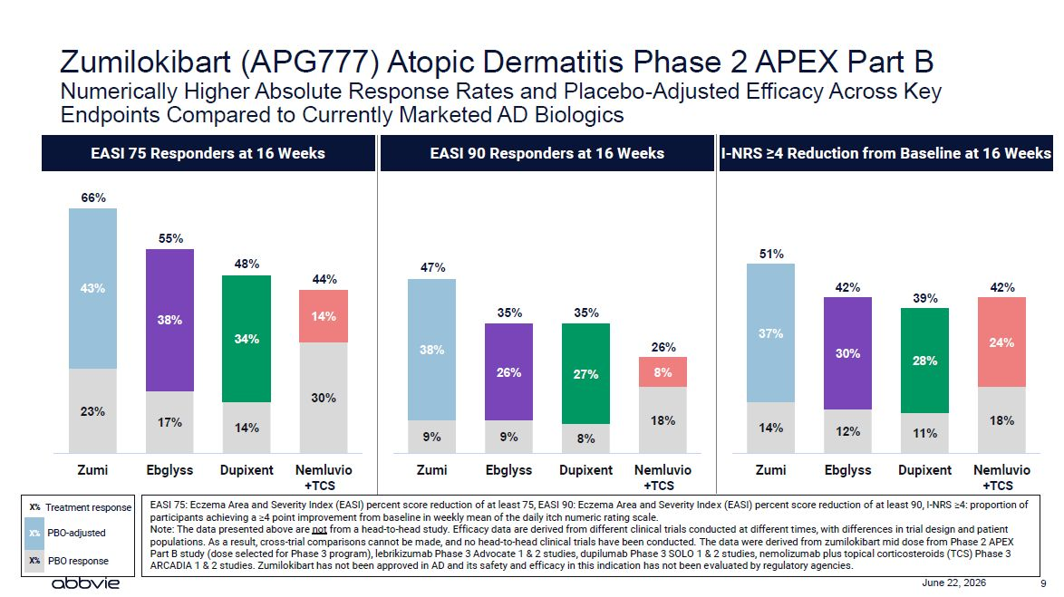
9 June 22, 2026 Zumilokibart (APG777) Atopic Dermatitis Phase 2 APEX Part B Numerically Higher Absolute Response Rates and Placebo-Adjusted Efficacy Across Key Endpoints Compared to Currently Marketed AD Biologics 23% 43% Zumi EASI 7 X% Treatment response X% PBO-adjusted X% PBO response 66% s 5 Responders at 16 Weeks 55% 48% 44% 38% 14% 34% 30% 17% 14% Ebglyss Dupixent Nemluvio +TCS EASI 90 Responders at 16 Weeks 47% 35% 35% 38% 26% 26% 27% 8% 18% 9% 9% 8% Zumi Ebglyss Dupixent Nemluvio +TCS I-NRS ≥4 Reduction from Baseline at 16 Week 51% 42% 42% 39% 37% 24% 30% 28% 18% 14% 12% 11% Zumi Ebglyss Dupixent Nemluvio +TCS EASI 75: Eczema Area and Severity Index (EASI) percent score reduction of at least 75, EASI 90: Eczema Area and Severity Index (EASI) percent score reduction of at least 90, I-NRS ≥4: proportion of participants achieving a ≥4 point improvement from baseline in weekly mean of the daily itch numeric rating scale. Note: The data presented above are not from a head-to-head study. Efficacy data are derived from different clinical trials conducted at different times, with differences in trial design and patient populations. As a result, cross-trial comparisons cannot be made, and no head-to-head clinical trials have been conducted. The data were derived from zumilokibart mid dose from Phase 2 APEX Part B study (dose selected for Phase 3 program), lebrikizumab Phase 3 Advocate 1 & 2 studies, dupilumab Phase 3 SOLO 1 & 2 studies, nemolizumab plus topical corticosteroids (TCS) Phase 3 ARCADIA 1 & 2 studies. Zumilokibart has not been approved in AD and its safety and efficacy in this indication has not been evaluated by regulatory agencies.

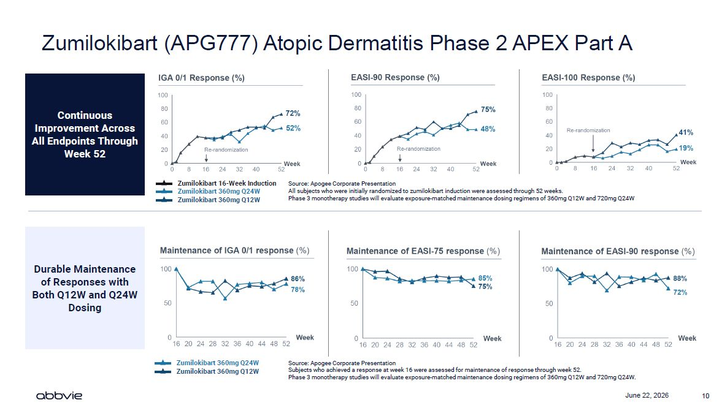
10 June 22, 2026 Zumilokibart (APG777) Atopic Dermatitis Phase 2 APEX Part A Zumilokibart 360mg Q24W Zumilokibart 360mg Q12W Continuous Improvement Across All Endpoints Through Week 52 Zumilokibart 16-Week Induction Zumilokibart 360mg Q24W Zumilokibart 360mg Q12W Durable Maintenance of Responses with Both Q12W and Q24W Dosing Source: Apogee Corporate Presentation All subjects who were initially randomized to zumilokibart induction were assessed through 52 weeks. Phase 3 monotherapy studies will evaluate exposure-matched maintenance dosing regimens of 360mg Q12W and 720mg Q24W Source: Apogee Corporate Presentation Subjects who achieved a response at week 16 were assessed for maintenance of response through week 52. Phase 3 monotherapy studies will evaluate exposure-matched maintenance dosing regimens of 360mg Q12W and 720mg Q24W.

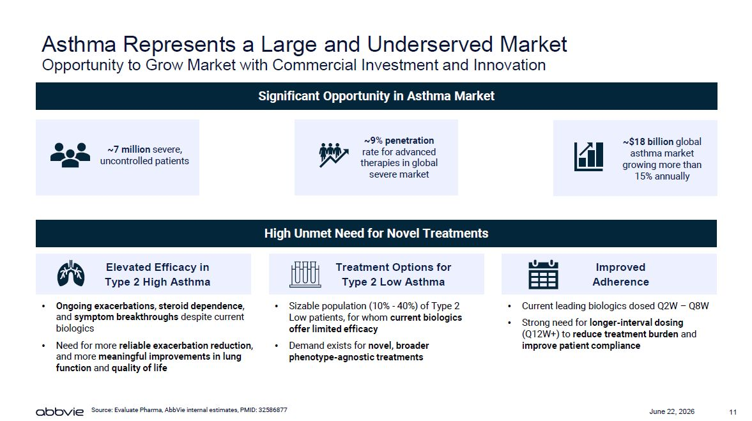
11 June 22, 2026 Asthma Represents a Large and Underserved Market Opportunity to Grow Market with Commercial Investment and Innovation Significant Opportunity in Asthma Market Treatment Options for Type 2 Low Asthma Elevated Efficacy in Type 2 High Asthma Improved Adherence Ongoing exacerbations, steroid dependence, and symptom breakthroughs despite current biologics Need for more reliable exacerbation reduction, and more meaningful improvements in lung function and quality of life Sizable population (10% - 40%) of Type 2 Low patients, for whom current biologics offer limited efficacy Demand exists for novel, broader phenotype-agnostic treatments Current leading biologics dosed Q2W – Q8W Strong need for longer-interval dosing (Q12W+) to reduce treatment burden and improve patient compliance ~7 million severe, uncontrolled patients ~9% penetration rate for advanced therapies in global severe market ~$18 billion global asthma market growing more than 15% annually High Unmet Need for Novel Treatments Source: Evaluate Pharma, AbbVie internal estimates, PMID: 32586877

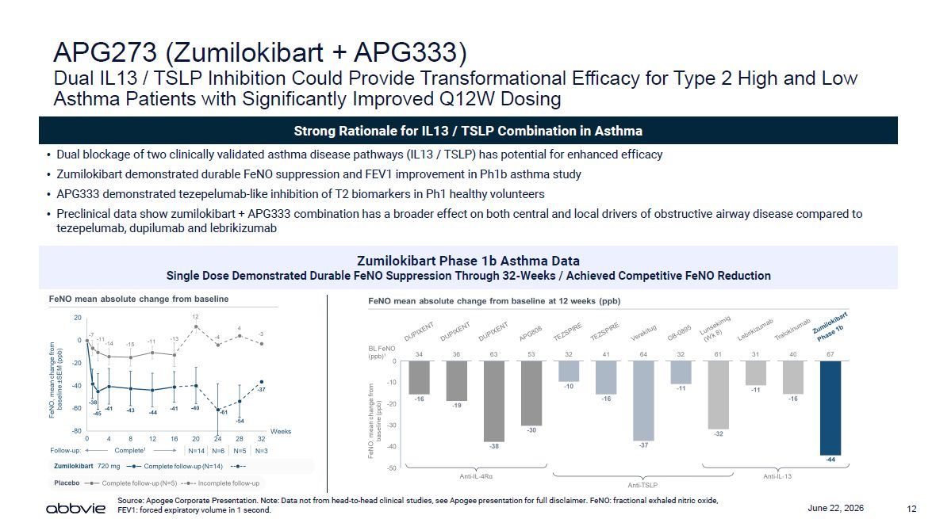
12 June 22, 2026 APG273 (Zumilokibart + APG333) Dual IL13 / TSLP Inhibition Could Provide Transformational Efficacy for Type 2 High and Low Asthma Patients with Significantly Improved Q12W Dosing Strong Rationale for IL13 / TSLP Combination in Asthma Source: Apogee Corporate Presentation. Note: Data not from head-to-head clinical studies, see Apogee presentation for full disclaimer. FeNO: fractional exhaled nitric oxide, FEV1: forced expiratory volume in 1 second. Dual blockage of two clinically validated asthma disease pathways (IL13 / TSLP) has potential for enhanced efficacy Zumilokibart demonstrated durable FeNO suppression and FEV1 improvement in Ph1b asthma study APG333 demonstrated tezepelumab-like inhibition of T2 biomarkers in Ph1 healthy volunteers Preclinical data show zumilokibart + APG333 combination has a broader effect on both central and local drivers of obstructive airway disease compared to tezepelumab, dupilumab and lebrikizumab Zumilokibart Phase 1b Asthma Data Single Dose Demonstrated Durable FeNO Suppression Through 32-Weeks / Achieved Competitive FeNO Reduction

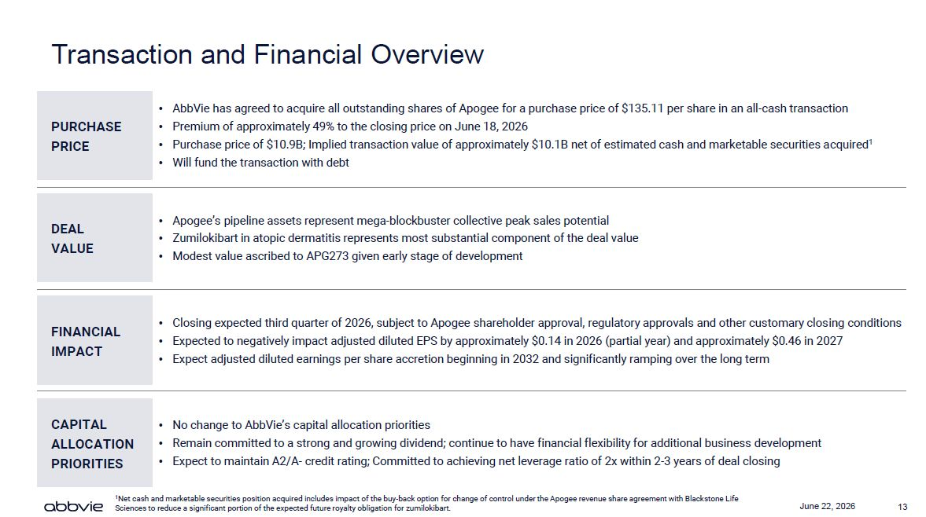
13 June 22, 2026 Transaction and Financial Overview AbbVie has agreed to acquire all outstanding shares of Apogee for a purchase price of $135.11 per share in an all-cash transaction Premium of approximately 49% to the closing price on June 18, 2026 Purchase price of $10.9B; Implied transaction value of approximately $10.1B net of estimated cash and marketable securities acquired1 Will fund the transaction with debt PURCHASE PRICE Apogee’s pipeline assets represent mega-blockbuster collective peak sales potential Zumilokibart in atopic dermatitis represents most substantial component of the deal value Modest value ascribed to APG273 given early stage of development DEAL VALUE CAPITAL ALLOCATION PRIORITIES FINANCIAL IMPACT Closing expected third quarter of 2026, subject to Apogee shareholder approval, regulatory approvals and other customary closing conditions Expected to negatively impact adjusted diluted EPS by approximately $0.14 in 2026 (partial year) and approximately $0.46 in 2027 Expect adjusted diluted earnings per share accretion beginning in 2032 and significantly ramping over the long term No change to AbbVie’s capital allocation priorities Remain committed to a strong and growing dividend; continue to have financial flexibility for additional business development Expect to maintain A2/A- credit rating; Committed to achieving net leverage ratio of 2x within 2-3 years of deal closing 1Net cash and marketable securities position acquired includes impact of the buy-back option for change of control under the Apogee revenue share agreement with Blackstone Life Sciences to reduce a significant portion of the expected future royalty obligation for zumilokibart.

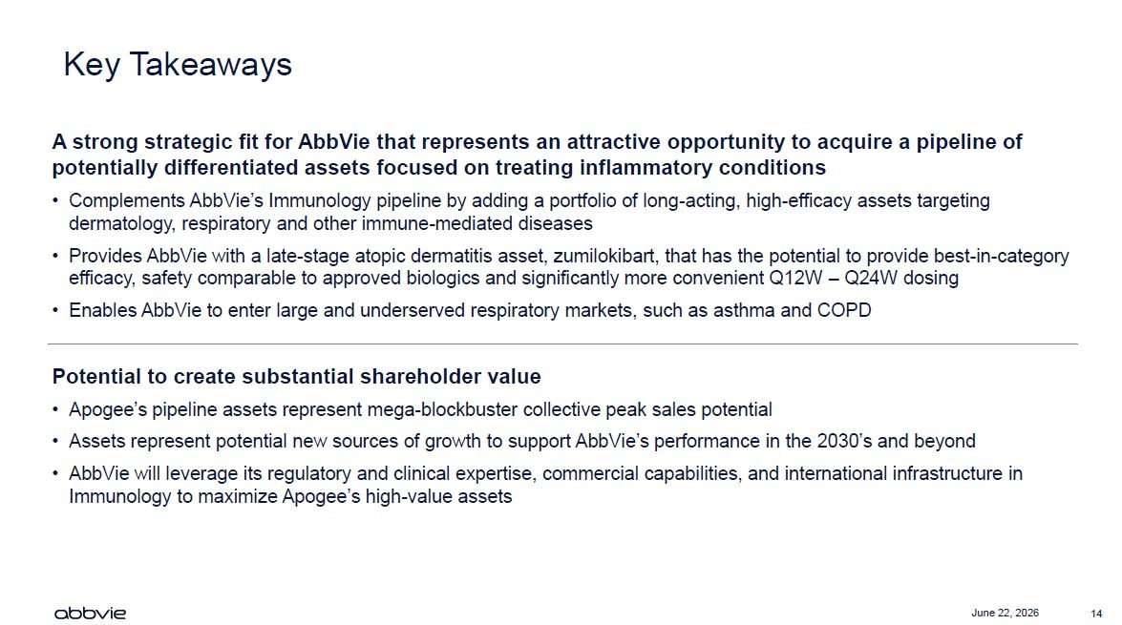
14 June 22, 2026 Key Takeaways A strong strategic fit for AbbVie that represents an attractive opportunity to acquire a pipeline of potentially differentiated assets focused on treating inflammatory conditions Complements AbbVie’s Immunology pipeline by adding a portfolio of long-acting, high-efficacy assets targeting dermatology, respiratory and other immune-mediated diseases Provides AbbVie with a late-stage atopic dermatitis asset, zumilokibart, that has the potential to provide best-in-category efficacy, safety comparable to approved biologics and significantly more convenient Q12W – Q24W dosing Enables AbbVie to enter large and underserved respiratory markets, such as asthma and COPD Potential to create substantial shareholder value Apogee’s pipeline assets represent mega-blockbuster collective peak sales potential Assets represent potential new sources of growth to support AbbVie’s performance in the 2030’s and beyond AbbVie will leverage its regulatory and clinical expertise, commercial capabilities, and international infrastructure in Immunology to maximize Apogee’s high-value assets



